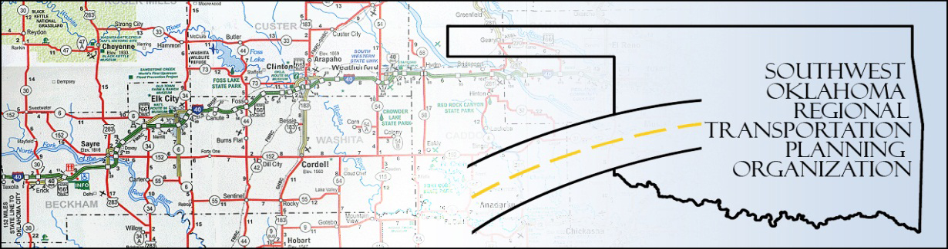

SORTPO

Policy Board Minutes
SWODA Conference Room
Building 420 Sooner Drive
Burns Flat, OK 73624
Thursday, June 25, 2015
10:30 a.m.

Policy Board Members | P/A | Policy Board Members | P/A
Brent Almquist | P | Debora Glasgow | P
Anita Archer | A | Lyle Miller | P
Cary Carrell | A | Heather Sheppard | A
Jeff Casida | P | Mark Skiles | A
Jerry Dean | P | Clark Southard | P
Marilyn Feaver | P | Bill Spurlock | A
Mike Galloway | A

- Call to Order:

Chairman Lyle Miller welcomed members, guests and called the meeting to order.

- Roll Call:

Roll was called and it was declared a quorum was present. Also in attendance were SWODA staff members Alex Damon and Jana Harris, ODOT Representative Laura Chaney and RPO Consultant Julie Sanders.

3. Approval of Minutes.:

The minutes of the May 21, 2015 meeting was discussed. Motion was made to approve the minutes by Jeff Casida and seconded by Clark Southard, all in favor.

4. Discussion Items:

a. Alex Damon held discussion on the Custer County LRPT Public Hearing noting that there were only a few minor changes received and how the plan would be modified to accommodate those recommendations. He also explained the next steps to be taken by the jurisdictions in Custer County to get the LRPT adopted. Once the plan is adopted copies will be made and distributed throughout the county.

b. Laura Chaney explained what the Transportation Alternative Program (TAP) entailed and the next steps that need to be taken to go forward with the program. After discussion about the program and questions asked a motion was made by Clark Southard and seconded by Jeff Casida to proceed, all in favor.

5. New Business:

Alex Damon explained that an RFP needs to been done to continue the Long Range Transportation Plan (LRTP) participation in Beckham and Roger Mills County’s. He also discussed about the upcoming meeting dates.

6. Remarks by Members:

None at this time.

7. Remarks by Guest:

None at this time.

8. Adjourn:

Being no further business, motion to adjourn was made by Jerry Dean and seconded by Clark Southard.

ATTEST:

___________________________ _________________________
(Chairman) (Secretary)

