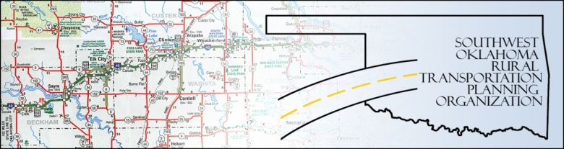

SORTPO TECHNICAL COMMITTEE MEETING March 3, 2015
Meeting Minutes
Attendance: Basil Weatherly Monty Proffitt
Mike Weixel Jim Mason
Elesia Church Alex Damon (staff)
Laura Chaney Lee Littrell
The technical committee meeting was called to order by Alex Damon at 10:35am.
After roll call, the minutes of the January 15th meeting were approved. Motion by Mason, Second by Proffitt, all in favor.
Discussion to make recommendations to the Policy Board in the following topics:
- SORTPO Civil Rights Policies (from handouts provided) : all members in consensus to recommend the policy to the Policy Board. Laura Chaney helped to explain the necessity of the inclusion.
Additional Conversations regarding the changes to the 2016 PWP (Planning Work Program), as well as the newest draft of the 2015 Custer County Long-Range Transportation Plan.

Discussion of meeting date: the Technical Committee will continue to meet on the 3rd Thursday monthly; the intention is for the Policy Board to meet on the 4th Thursday monthly.

Meeting was adjourned at 12.18 pm.

