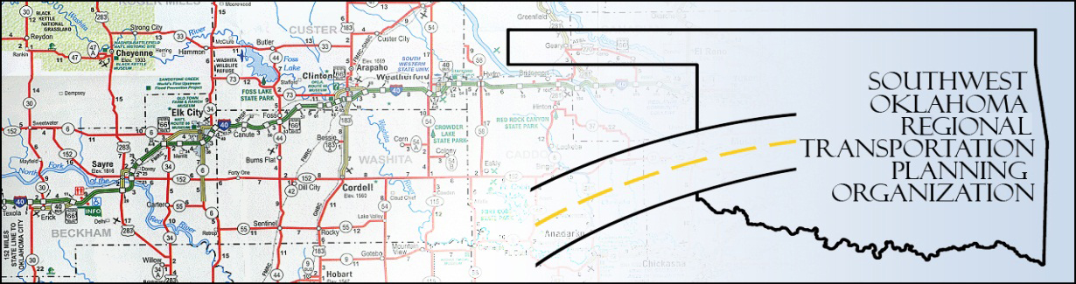

SORTPO

Technical Committee Minutes
SWODA Conference Room
Building 420 Sooner Drive
Burns Flat, OK 73624
Thursday, June 18, 2015
1:30 p.m.
Technical Committee Members | P/A | Technical Committee Members | P/A
Laura Chaney | A | Monty Profitt | A
Elesia Church | P | Joe Ridley | A
Alex Damon | P | Julie Sanders | A
Jana Harris | P | Tim Tutten | A
Lee Littrell | A | Basil Weatherly | P
Jim Mason | P | Mike Weixel | A

1. Call to Order:
The technical committee meeting was called to order by Alex Damon.

2. Roll Call – Introductions:

After roll call it was declared a quorum was present. Jessica Scott with the Oklahoma Department of Transportation came in place of Laura Chaney, Tom Zigler, Director of Community and Economic Development, Ronnie Ward, Executive Director with Association of South Central Oklahoma Governments (ASCOG), Rich Rogalski, Lawton Metropolitan Planning Organization (LMPO), Debora Glasgow, Executive Director with South Western Oklahoma Development Authority (SWODA) was introduced.

3. Approval of Minutes:

The minutes of the April 16th meeting were discussed. Motion was made by Jim Mason to approve minutes as is and seconded by Elesia Church, all in favor.
4. Discussion of Long Range Transportation Plan (LRTP) 30-day Public Review and Comment Period:

Alex Damon discussed that there has been a few minor comments received during the public review and comment period. He explained what the comments were and how the plan would be modified to accommodate those recommendations. He stated that he now has all transit maps for the tribes and they will be inserted into the plan.

5. Discuss and Consider Recommendations Regarding the Transportation Alternative Program (TAP):

Jessica Scott and Jana Harris went into a large amount of detail and discussion regarding the Transportation Alternative Program (TAP) and what would be expected of SORTPO and what they need to do.
6. Discussion of the RFP for Continued LRTP’s for SWODA/SORTPO Region:

Alex Damon explained that an RFP needs to been done to continue the Long Range Transportation Plan (LRTP) participation in Beckham and Roger Mills County’s.

7. New Business:

The next Technical meeting will be July 16th at 10:00 a.m. There was no other new business at this time.

8. Reports and Comments:

There were none at this time.

9. Adjourn:

Basil Weatherly made a motion to adjourn and Elesia Church seconded the motion, all in favor. Meeting was adjourned at 2:59 p.m.

