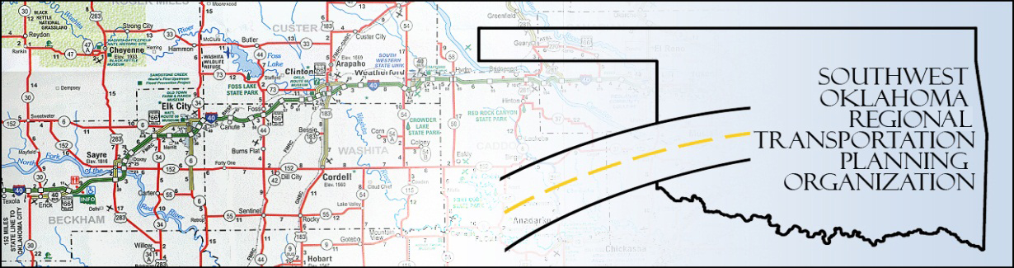

SORTPO

Technical Committee Minutes
SWODA Conference Room Building 420 Sooner Drive Burns Flat, OK 73624
Thursday, January 21, 2016
10:00 a.m.
Technical Committee Members | P/A | Technical Committee Members | P/A
Laura Chaney | P | Jeff Morton (not official member until Feb) | A
Elesia Church | P | Monty Profitt | P
Alex Damon | P | Joe Ridley | A
Jana Harris | P | Tim Tutten | A
Lee Littrell | A | Basil Weatherly | A
Jim Mason | P | Mike Weixel | A

1. Call to Order:
The technical committee meeting was called to order by Alex Damon.

2. Roll Call – Introductions: (declaration of quorum)

3. Approval of Minutes:

The minutes of the August 20th meeting were discussed. Motion was made by Jana Harris to approve minutes and seconded by Elesia Church, all in favor.
4. Discuss and consider recommendations to the Policy Board regarding updates to the Planning Work Program (PWP):
Content of PWP approved; Membership list changes: Remove Julie Sanders, change position (title) for Basil Weatherly. Jim Mason moved to recommend with changes noted; Elesia Church seconded, all in favor.

5. Discuss and consider recommendations to the Policy Board regarding the updates to the Public Participation Plan (PPP):
Content approved; 45-day public comment period to be set by Policy Board (can start on 1/28). Jim Mason moved approval, Monty Profitt seconded, all in favor.

6. Discuss updates and the applications to Transportation Alternatives Grant Program (TAP) through ODOT.
Engineering costs reimbursable only through pre-qualified list from ODOT website; additional discussion of local entities applying, progress update. Also, applications that coordinate TAP with another grant (i.e. CDBG) will likely score higher.

7. Calendar of Meeting for 2016 distributed.

8. Receive report of progress for Roger Mills County LRTP.
LRTP (Roger Mills and Beckham Counties) to use 2010 as base date for data collection. Already determined to plan through 2040 from previous meetings.

9. No New Business

Jana Harris made a motion to adjourn and Elesia Church seconded the motion, all in favor. Meeting was adjourned at 10:55 a.m.

