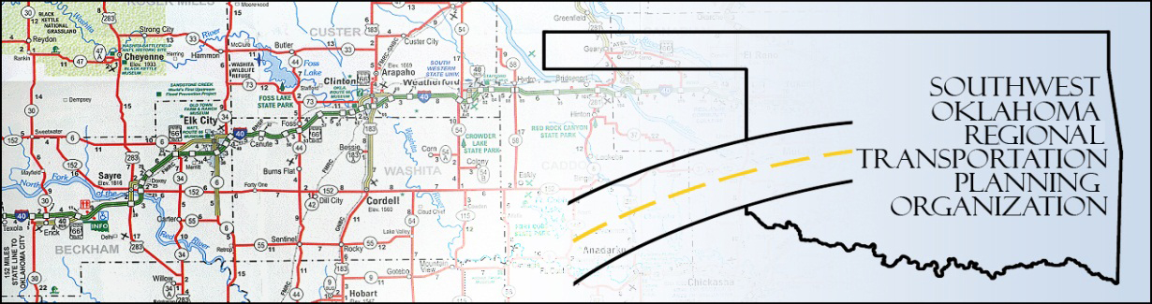

SORTPO

Technical Committee Minutes
SWODA Conference Room Building 420 Sooner Drive Burns Flat, OK 73624
Thursday, March 17, 2016
10:00 a.m.
Technical Committee Members | P/A | Technical Committee Members | P/A
Laura Chaney | A | Jeff Morton | A
Elesia Church | P | Monty Profitt | A
Alex Damon | P | Joe Ridley | A
Jana Harris | A | Tim Tutten | A
Lee Littrell | A | Basil Weatherly | P
Jim Mason | A | Mike Weixel | A

1. Call to Order:
The technical committee meeting was called to order by Alex Damon.

2. Roll Call – Introductions

3. Approval of Minutes:

The minutes of the January 21st meeting were discussed. Motion was made by Basil Weatherly to approve minutes and seconded by Elesia Church, all in favor.
4. Discuss and consider recommendations to the Policy Board regarding the updates to the Public Participation Plan (PPP):
Following 45-day public comment period; changes made include removal of TIP & references, changing of all “Rural” titles and descriptions to “Regional”. These changes are already reflected in the current PPP draft.

5. Discuss and/or vote to recommend to the Policy Board to adopt the 2016 PPP: Elesia Church moved approval and recommendation to Policy Board, Basil Weatherly seconded, all in favor.

6. Discuss updates and the applications to Transportation Alternatives Grant Program (TAP) through ODOT.
Discussion and updates provided. Dates of preliminary application deadlines discussed.

7. Receive report of progress for Roger Mills County LRTP. Discussion of nest “Public Information Meeting” (aka Stakeholder’s Meeting) & who to invite for Beckham County. Note: Rick Garrison (formerly of Cheyenne) is new Superintendant of Elk City Schools.

8. New Business: None at this time

9. Elesia Church moved adjournment, Basil Weatherly seconded; meeting adjourned at 10:55am.

