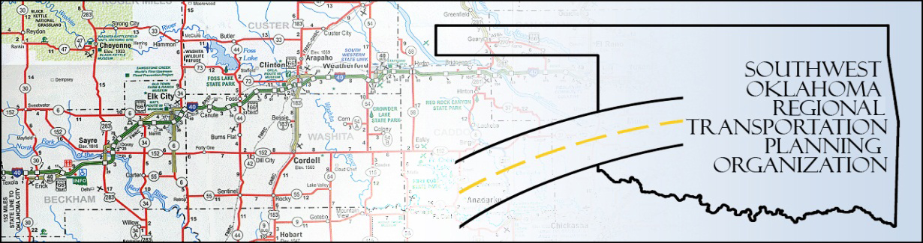

SORTPO

Technical Committee Minutes
SWODA Conference Room Building 420 Sooner Drive Burns Flat, OK 73624
April 21, 2016
10:00 a.m.
Technical Committee Members | P/A | Technical Committee Members | P/A
Laura Chaney | P | Jeff Morton | P
Elesia Church | P | Monty Profitt | P
Becky Cockrell | P | Joe Ridley | A
Jana Harris | P | Tim Tutten | A
Lee Litterell | A | Basil Weatherly | P
Jim Mason | A | Mike Weixel | A

1. Call to Order:
The technical committee meeting was called to order by Jana Harris.

2. Roll Call – Introductions

3. Approval of Minutes:

The minutes of the March 17th meeting were discussed. Motion was made by Basil Weatherly to approve minutes and seconded by Elesia Church, all in favor.
4. Discuss and consider recommendations to the Policy Board regarding the changes to the SORTPO Planning Work Program 2016 (PWP). The following changes were made to the PWP. Budget Amendments and Transportation Alternatives Grant Program (TAP) were added to the Short Range Transportation Planning section, Visualization techniques was deleted out all elements and we added collaborate with ODOT on freight management. Elesia Church moved to approve and made the recommendation to be presented at the Policy Board meeting, Basil Weatherly seconded, all in favor.

5. Discuss updates and the applications for Transportation Alternatives Grant Program (TAP) through ODOT. ODOT received 117 applications. Each planning organization will have two months to score and approve the applications. The applications will be scored and approved by the Tech Committee then presented at the next Policy Board meeting. Motion was made by Elesia Church to approve and recommend to the Policy Board, seconded by Basil Weatherly all in favor.

6. Discuss and consider recommending to SORTPO Policy Board the following:

- Key issues, trends and challenges for Beckham County LRTP and Roger Mills LRTP. Identified the different challenges, issues and trends for both counties refer to the spreadsheet of the identified topics– Jeff Morton made the motion to approve and Monty Profitt seconded, motion carried. Will be presented at the next Policy Board Meeting for discussion and approval
- Discuss Goal categories for the Beckham County LRTP and Roger Mills LRTP and provided direction to staff. Identified importance of every goal and the effects it has on the counties and what was important for that county to continue to grow and be more effective. Elesia moved to approval to forward to the Policy Board and Basil Weatherly seconded, all in favor.
- 2035 Population and employment projections for Beckham County LRTP and Roger Mills LRTP. Identified about the aging population in Roger Mills and how the elderly are moving into Elk City because of health care and convenience. Discuss how now that the oil field work has declined it can be an advantage to Elk City for retail stores moving in because they have people that need jobs. Monty Profitt moved the approval and Elesia Church second, all in favor.

8. New Business: FHWA performance freight and Air Quality

9. Reports and Comments: For public outreach it was discussed to speak at different civic organizations such as Rotary.

10. Elesia Church moved adjournment, Monty Profitt seconded.

