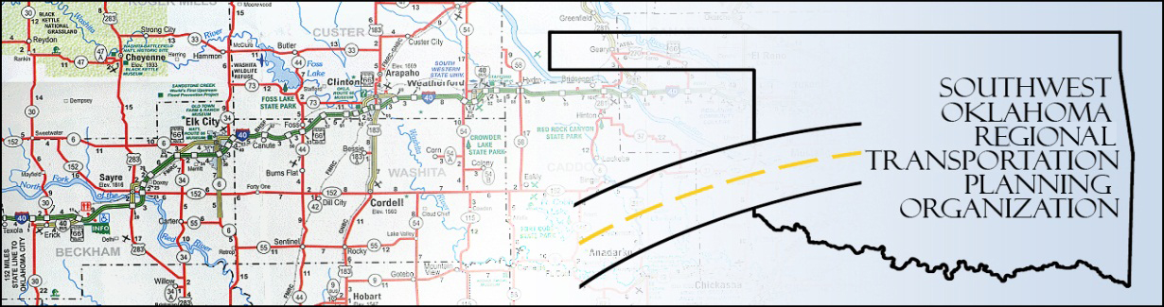

SORTPO

Policy Board Minutes
SWODA Conference Room
Building 420 Sooner Drive Burns Flat, OK 73624
Thursday, April 28, 2016
10:30 a.m.

Policy Board Members | P/A | Policy Board Members | P/A
Brent Almquist | A | Debora Glasgow | P
Anita Archer | P | Lyle Miller | P
Cary Carrell | A | Cendie Newman | A
Jeff Casida | P | Heather Sheppard | P
Jerry Dean | A | Mark Skiles | P
Marilyn Feaver | P | Clark Southard | P
Mike Galloway | P | Bill Spurlock | P

- Call to Order:

Meeting called to order at 10:36 a.m. by Chairman Lyle Miller

- Roll Call: and declaration of quorum by Becky Cockrell.

3. Approval of Minutes: The minutes of the March 24, 2016 were discussed with a change to show that Marilyn Feaver was not at present at the March 24, 2016 meeting. Motion was made by Jeff Casida to approve the minutes with change and seconded by Bill Spurlock, motion passed.

- Discuss and consider recommendations regarding the changes to the SORTPO Planning Work Program 2016 (PWP) – Information was presented by Staff showing minor changes to the 2016 PWP to include the addition of the Transportation Alternative Program (TAP) application process as a task in Element 4 Short Range. There were no changes to the total amount of funding. Motion was made by Clark Southard and seconded by Marilyn Feaver, motion passed.

- Discuss updates and the applications to the Transportation Alterative Program (TAP). Becky Cockrell presented information on the TAP applications, 14 applications were submitted for projects in ODOT Division 7 and 4 applications submitted for projects in ODOT Division 5. Cockrell traveled to the 4 communities (Bessie, Elk City, Hobart and Thomas) in Division 4 and met with city staff about their issues and visions. The deadline for the TAP application is April 29, 2016. A second round of TAP funding will be available in January – February 2017.

6. Discuss and consider approving:
A. Key Issues, trends and challenges for Beckham County LRTP and Roger Mills LRTP. Mike Galloway commented when the oil field slows down, the wife starts back to working. People start repairing instead of replacing items. Repair of equipment has increased so business that support repair has increased. Anita Archer has seen an increase in younger men working. Debora Glasgow stated the workforce has changed in the last year, people are working 2-3 jobs. Bill Spurlock commented that school age kids have a harder time finding a job. Motion by Marilyn Feaver to approve the key issues, trends and challengers as recommended by the SORTPO Technical Committee, Clark Southard seconded the motion. Motion passed.
B. Goal categories for the Beckham County LRTP and Roger Mills LRTP. Clark Southard commented on the table that indicated no Goal for Environment. Mike Galloway recommends putting Environment under the community & health goal. Lyle Miller recommends leaving Environment as a separate goal. Anita Archer agrees with Chairman Miller. Motion by Clark Southard to approve the goal categories as recommended by the SORTPO Technical Committee and include Environment as a goal category, Marilyn Feaver seconded the motion. Motion passed.
C. 2035 Population and Employment projections for Beckham County LRTP and Roger Mills LRTP. Jeff Casida states there are many variables for population in this region. The region’s population is influenced by unpredictable oil and gas industry. Clark Southard recommends that Julie Sanders contact Dr. Whitaker and Dr. Kunz at OSU Agriculture Economics to obtain additional information concerning population in Beckham and Roger Mills Counties. This information to brought back to the Policy Board at their next meeting. Motion by Clark Southard to table this item until next meeting and Anita Archer seconded. The motion passed.

7. New Business: Not at this time
8. Reports and Comments.

9. Being no further business, motion to adjourn was made by Clark Southard, seconded by Anita Archer. Meeting was adjourned at 11:05.

ATTEST:

___________________________ _________________________
(Chairman) (Secretary)

