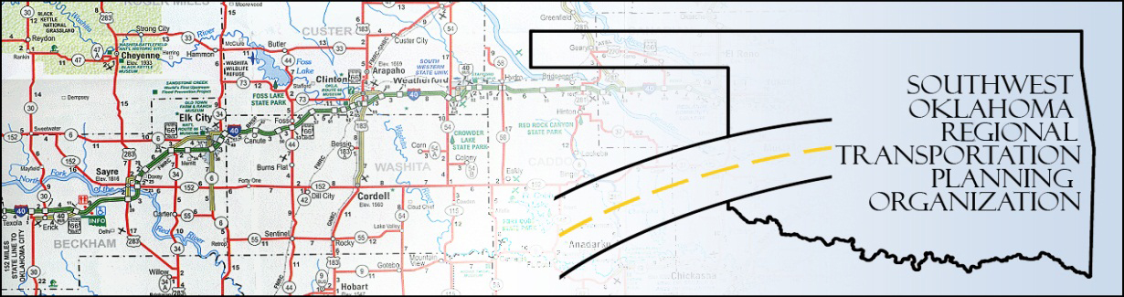

SORTPO

Policy Board Minutes
SWODA Conference Room
Building 420 Sooner Drive Burns Flat, OK 73624
Thursday, June 23, 2016
10:30 a.m.

POLICY BOARD MEMBERS | P/A | POLICY BOARD MEMBERS | P/A
Brent Almquist | A | Debora Glasgow | P
Anita Archer | P | Lyle Miller | P
Kirk Butler | P | Cendie Newman | A
Jeff Casida | P | Heather Sheppard | A
Jerry Dean | A | Mark Skiles | P
Marilyn Feaver | P | Clark Southard | P
Mike Galloway | A | Bill Spurlock | P

1. Call to Order:
Meeting called to order at 10:30 a.m. by Chairman Lyle Miller.

2. Roll Call and declaration of quorum:
By Jana Harris –quorum declared

3. Approval of Minutes:

The minutes of the May 26, 2016 were approved with no change. Motion was made by Clark Southard to approve the minutes with Kirk Butler abstained (because Kirk Butler was not at the last meeting) and seconded by Jeff Casida, motion passed.

4. Discuss and consider approving 2035 Population and employment projections for Beckham County LRTP and Roger Mills County LRTP.
Motion made by Anita Archer that Beckham County projections be at 1% annual growth for population and seconded by Bill Spurlock.
Motion made by Clark Southard that Beckham County projections be at 1% annual growth for employment and seconded by Anita Archer.
Motion made by Clark Southard that Roger Mills County projections be at 1% annual growth for population and seconded by Jeff Casida.
Motion made by Clark Southard that Roger Mills County projections be at 1% annual growth for employment and seconded by Jeff Casida.

5. New Business:
LRTP for Beckham and Roger Mills County will be ready in October. A special meeting of the policy board will need to be held around the 1st of August to review and approve the LRTP for Beckham and Roger Mills Counties.
6. Reports and Comments: Becky Cockrell will send out chapters 4, 5 and 6 to the Policy board members that were not able to attend the meeting.
Being no further business, motion made by Mark Skiles and second by Jeff Casida, motion passed to adjourn the meeting. Meeting was adjourned at 12:30 p.m.

ATTEST:

___________________________ _________________________
(Chairman) (Secretary)

