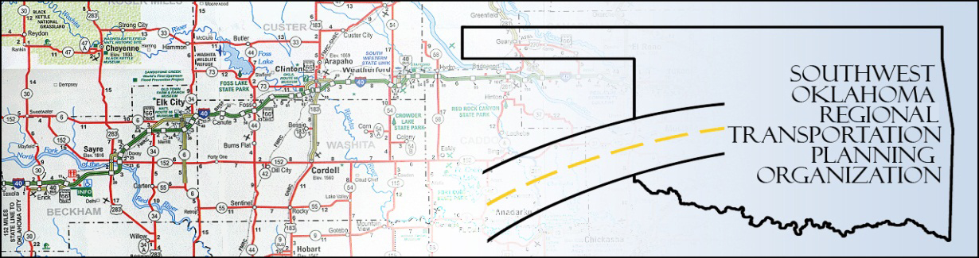

SORTPO Policy Board

Special Amended Meeting Agenda
SWODA Conference Room
Building 420 Sooner Drive
Burns Flat, OK 73624
September 29, 2016, 10:05 a.m.
- Call to Order
- Roll Call – declaration of a quorum
- Approval of Minutes for the August 25, 2016 meeting.
- Discuss the results of the public review and comment period for the 2036 Beckham County LRTP.
- Vote to approve or disapprove the 2036 Beckham County LRTP.
- Discuss the results of the public review and comment period for the 2036 Roger Mills County LRTP.
- Vote to approve or disapprove the 2036 Roger Mills County LRTP.
- Discuss the results of public review and comment period for the amendment to the Custer County LRTP.
- Vote to approve or disapprove the amendment to the 2035 Custer County LRTP.
- Discuss and vote to approve updated Planning Work Program (PWP).
- Approve Resolution for the Roger Mills and Beckham County 2036 LRTP.
- New Business.

- Report and Comments

- Adjourn

