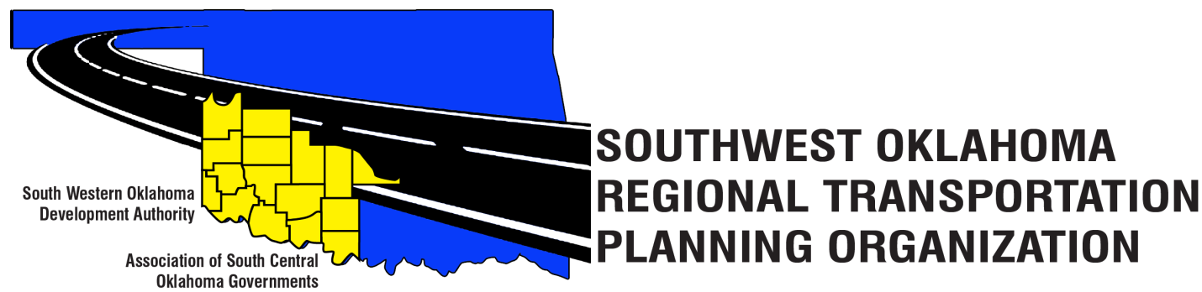

SORTPO Technical Committee

Special Meeting Agenda
SWODA Conference Room
Building 420 Sooner Drive Burns Flat, OK 73624
December 8, 2016 9:00 a.m.

- Call to Order

- Roll Call – Introductions

- Approval of the minutes for the September 29, 2016 meeting.

- Discuss and consider action on the amended PWP

- Discuss and consider the amendment for the updated By-Laws for the 2017 PWP

- Discuss and consider setting a 45-day public review period amending the PPP

- Discuss and take action on the 2017 meeting schedule

- New Business

- Reports and Comments

- Adjourn

