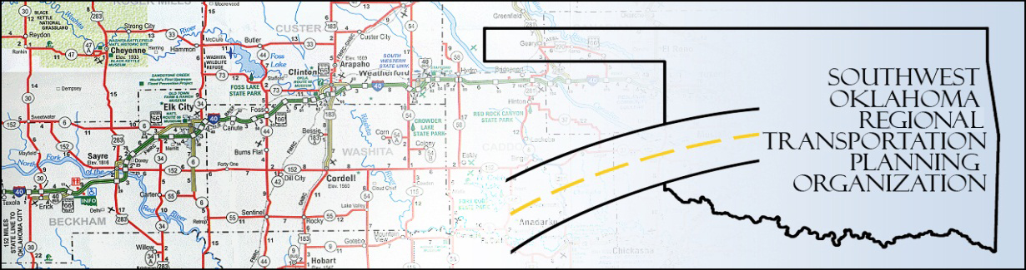

SORTPO

Technical Committee Minutes
(Special Meeting)
SWODA Conference Room Building 420 Sooner Drive Burns Flat, OK 73624
August 24, 2016
10:00 a.m.
Technical Committee Members | P/A | Technical Committee Members | P/A
Laura Chaney | A | Jeff Morton | A
Elesia Church | P | Monty Profitt | A
Becky Cockrell | P | Basil Weatherly | P
Jana Harris | P | Mike Weixel | A
Lee Litterell | A
Jim Mason | P

1. Call to Order:
The technical committee meeting was called to order by Becky Cockrell.

2. Roll Call – Introductions

3. Approval of Minutes:

The minutes of the May 19, 2016 meeting were discussed. Motion was made by Basil Weatherly to approve minutes and seconded by Elesia Church, motion passed.
4. Discuss the revised 2036 Population and Employment Projections for Beckham County and Roger Mills County LRTPs approved by the SORTPO Policy Board. Julie Sanders presented information from what the SORTPO Policy Board had approved for population and employment projection for the 2036 Beckham County and Roger Mills County LRTP. No action needed.

5. Discuss, provide comments and recommend the SORTPO Policy Board to established a 30-day public review and comment period prior to adoption of the 2036 Beckham County LRTP. Julie Sanders asked for comments regarding Freight Routes, Planned Improvements and Areas of Concern for Beckham County. Basil Weatherly, Jim Mason and Elesia Church comment on some local areas and designated area for freight in Elk City area. Julie Sanders also asked what are some Planned Projects and Areas of Concern for Beckham County. Basil Weatherly, Eleisa Church and Jim Mason gave some information regarding some Planned Projects and some Area of Concern. Julie Sanders recommended adding tables to the 2036 Beckham County LRTP regarding these issues. Motion was made by Basil Weatherly and seconded by Elesia Church. Motion passed.

6. Discuss, provide comments and recommend the SORTPO Policy Board to established a 30-day public review and comment period prior to adoption of the 2036 Roger Mills County LRTP. Julie Sanders asked for some comments regarding Freight for Roger Mills County. Basil Weatherly, Jana Harris, and Elesia Church recommended some Freight Issues and Areas of Concern, for Roger Mills County. Julie Sander recommended adding some tables to the 2036 Roger Mills County LRTP. Motion was made by Jim Mason and seconded by Elesia Church. Motion passed.

7. Discuss, provide comments and recommend the SORTPO Policy Board established a 30-day public review and comment period prior to adoption of an amendment to the 2035 Custer County LRTP. During SORTPO Policy Board meeting in June 2016 a question was raised about the rate of growth develop for the 2035 Custer County LRTP. It was during this discussion that it was discovered that 20% was used as growth to correct this mistake staff utilized the same growth scenarios developed for the Roger Mills County and Beckham County LRTP. After discussion it was decided for a 5% growth per decade for population and a 4% employment growth per decade. Motion was made by Basil Weatherly and seconded by Elesia Church. Motion passed.

8. New Business:

9. Reports and Comments: Reminded the Tech. Committee that we would not have our meeting on September 15, 2016 but would have a special meeting on September 29, 2016 at 10:00 am.

10. Jana Harris moved adjournment, Basil Weatherly seconded.

