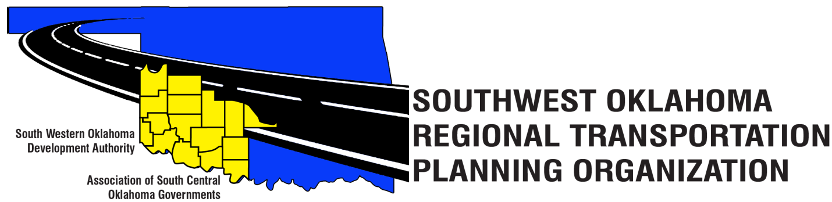

SORTPO

Technical Committee Minutes
(Special Meeting)
SWODA Conference Room Building 420 Sooner Drive Burns Flat, OK 73624
December 08, 2016
9:00 a.m.
Technical Committee Members | P/A | Technical Committee Members | P/A
Laura Chaney | A | Jeff Morton | P
Elesia Church | P | Monty Profitt | A
Becky Cockrell | P | Basil Weatherly | P
Jana Harris | P | Mike Weixel | A
Lee Litterell | P | Steve Kelly | P
Jim Mason | P

1. Call to Order:
The technical committee meeting was called to order by Becky Cockrell.

2. Roll Call – Introductions

3. Approval of Minutes: The minutes of the September 29, 2016 meeting were discussed. Motion was made by Basil Weatherly to approve minutes and seconded by Jim Mason, motion passed.

4. Discuss, provide comments and recommended the SORTPO Policy Board to approve amending the FFY 2017-18 PWP. Motion was made by Jim Mason and seconded by Basil Weatherly. Motion passed.

5. Discuss, provide comments and recommend the SORTPO Policy Board to approve amending the SORTPO Policy Board By-Laws. Motion was made by Basil Weatherly and seconded by Eleisa Church. Motion passed.

6. Discuss, provide comments and recommend the SORTPO Policy Board to established a 45-day public review and comment period amending the Public Participation Plan until February 16, 2017. Motion was made by Jim Mason and seconded by Lee Litteral. Motion passed.

7. Discuss, provide comments and recommend the SORTPO Policy Board 2017 meeting schedule. Motion was made by Basil Weatherly and seconded by Lee Litteral. Motion passed.

8. New Business:

9. Reports and Comments: Reminded the Tech. Committee that the 2017 calendar year meeting places will be in at the Western Tech. Center in Burns Flat, Ok. that live near SWODA the ones that live near ASCOG they will meet at Red River Tech. Center in Duncan, Ok. We will be having our meetings by teleconferences.

10. Basil Weatherly moved adjournment, Jeff Morton seconded.

