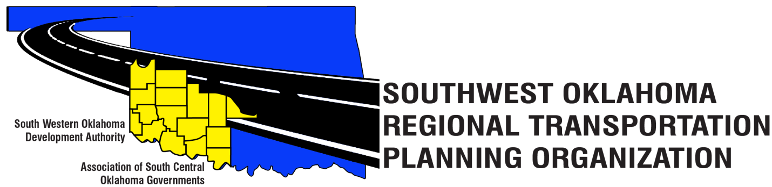
SORTPO Technical Committee

Meeting Agenda
February 16, 2017 10:00 a.m.
Western Technology Center  Adult Education Bldg,  621 Sooner Dr.  Burns Flat, OK 73624 | Red River Technology Center  JDM Business Center, Rm B113  3300 W. Bois D’Arc  Duncan, OK 73533
- Call to Order
- Roll Call – Introductions
- Approval of the minutes for the January 16, 2017 meeting.

- Discuss information contained in Table 1 SORTPO Technical Committee Topics and how the information will be collected and incorporated into the SORTPO Transportation Planning Process.

Table 1: SORTPO Technical Committee Topics
 | School Enrollment 2011-2016 | Population & Employment  Data | Stakeholder  Survey
Cotton | Attachment  1a | Attachment  1b | Handout at meeting
Greer | Attachment  2a | Attachment  2b | Handout at meeting
Harmon | Attachment  3a | Attachment  3b | Handout at meeting
Jackson | Attachment  4a | Attachment  4b | Handout at meeting
Jefferson | Attachment  5a | Attachment  5b | Handout at meeting
Stephens | Attachment  6a | Attachment  6b | Handout at meeting
Tillman | Attachment  7a | Attachment  7b | Handout at meeting

- Old Business

- Reports and Comments- SORTPO Data & Map Resource Book

- Adjourn

