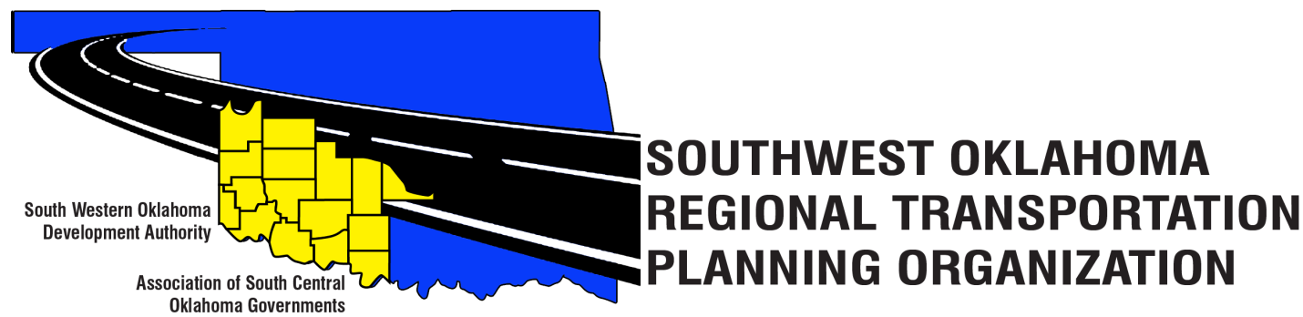

SORTPO

Technical Committee Minutes

Western Technology Center | Red River Technology Center
Adult Education Bldg 621 Sooner Dr. | JDM Business Center, Rm B113
Burns Flat, OK 73624 | Duncan, OK 73533

February 16, 2017
10:00 a.m.
Technical Committee Members | P/A | Technical Committee Members | P/A
Laura Chaney | P | Jeff Morton | A
Elesia Church | P | Monty Profitt | A
Becky Cockrell | P | Basil Weatherly | P
Jana Harris | A | Mike Weixel | A
Lee Litterell | P | Steve Kelly | P
Jim Mason | P | John Sheppard | P
Ty Phillips | P | Kevin Ouellette | P

1. Call to Order:
The technical committee meeting was called to order by Jana Harris.

2. Roll Call – Introductions:
Becky Cockrell- quorum declared

3. Approval of Minutes:
The minutes of the January 16, 2016 meeting were discussed. Motion was made by Basil Weatherly to approve minutes and seconded by Elesia Church, motion passed.

4. Discussion was held on the following information for School Enrollment, Population and Employment Projection for Cotton, Greer, Harmon, Jackson, Jefferson, Stephens and Tillman County. Information on these issues will be discussed at a later time and incorporated into the plan.

5. New Business:

6. Reports and Comments:

7. Adjourn:
Steve Kelly moved adjournment, Kevin Ouellette seconded.

