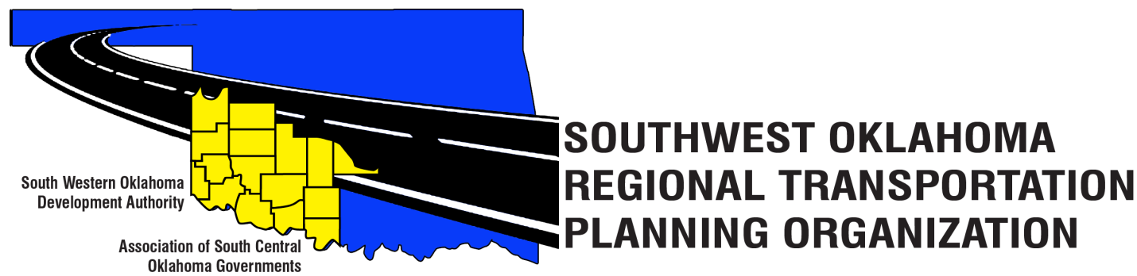

SORTPO

Policy Board Minutes

Western Technology Center | Red River Technology Center
Adult Education Bldg 621 Sooner Dr. | JDM Business Center, Rm B113
Burns Flat, OK 73624 | Duncan, OK 73533

January 26, 2017
10:30 a.m.
Policy Board Members | P/A | Policy Board Members | P/A
Brent Almquist | P | Debora Glasgow | A
Anita Archer | A | Lyle Miller | P
Dale Bunn | A | Cendie Newman | A
Kirk Butler | P | Lyle Roggow | A
Jeff Casida | P | Heather Sheppard | P
Jerry Dean | P | Mark Skiles | A
Jay Earp | P | Clark Southards | P
Marilyn Feaver | P | Bill Spurlock | P
Shawn Freie | P | Larry Thoma | A
Mike Galloway | P | Tom Zigler | P

1. Call to Order:
Meeting called to order at 10:40 a.m. by Chairman Lyle Miller.

2. Roll Call – Introductions:

By Becky Cockrell–quorum declared

3. Approval of Minutes:

The minutes of the December 8, 2016 meeting were discussed. Motion was made by Jeff Casida to approve minutes and seconded by Bill Spurlock, motion passed.

4. Discuss the Stakeholder’s Meeting Schedule:

Becky Cockrell and Tom Zigler shared the dates, times and places of the stakeholder’s meetings for Cotton, Greer, Harmon, Jackson, Jefferson, Stephens and Tillman Counties. Lyle Miller expresses to the Policy Board the importance of these Stakeholder’s meetings and if anyone from the Policy Board can attend it would have a big impact on our region and it would help in transportation planning process for each county.

5. Discuss and provided direction to the staff in collection of data, identification of key issues, concerns, trends and roles of public participation in the Transportation Planning Process:

Julie Sanders discussed that as we move forward into the transportation process that we need to reach out to the public. The stakeholder’s meetings will helps us as a staff to reach out to the key people in the communities to explain what the RTPO is. Also, we need their input in making this plan successful to identify key issues, concerns and trends for transportation plans. The staff has been gathering base year data for population and employment information from the 2010-2014 and 2011-2015 Civilian Labor Force. Data has been collected for the 2011-2014 for Greer, Harmon and Jackson. Mrs. Sanders discussed that we use a 20-year projection for these plans. She also discussed how the Technical Committee recommended that we try using the School Districts Average Daily Membership (ADM) for data population density resources. Clark Southard and Marilyn Feaver were concerned about the rail and airport information. Mrs. Sanders responded that data is collected for the rail and airports. Questions were asked about how the information was collected? Mrs. Sanders said the information is gathered from Aviation Administration on freight needs, location and other needs. Also there are members from the area that are on the Policy/ Tech. Board that can help with this data.

6. New Business:

None at this time.

7. Reports and Comments:

- Mrs. Sanders discussed how the Technical Committee decided to hold off on adding new Technical Committee members to the Board until after the stakeholder’s meetings for each county.

- Mrs. Sanders also discussed how that February was going to be a busy month and that February was not on the calendar to meet and we would need to do so. Becky Cockrell will resend updated calendars to the Policy Board. Motion was made by Jerry Dean and seconded by Bill Spurlock, motion passed.

- Marilyn Feaver would like for the Policy Board to be able to review the Technical Committee minutes before each Policy Board meeting.

8. Adjourn:

Clark Southard moved adjournment, Mike Galloway seconded.

