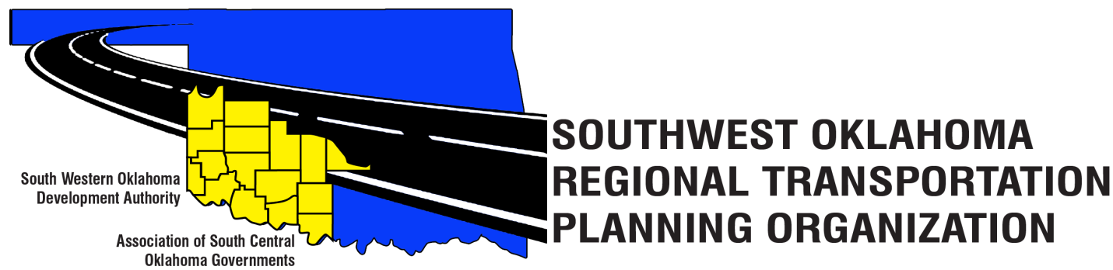

SORTPO

Policy Board Minutes
February 23, 2017
10:30 a.m.

Western Technology Center | Red River Technology Center
Adult Education Bldg | JDM Business Center, Rm B113
Burns Flat, OK 73624 | Duncan, OK 73533

Policy Board Members | P/A | Policy Board Members | P/A
Brent Almquist | P | Debora Glasgow | P
Anita Archer | P | Lyle Miller | P
Dale Bunn | P | Cendie Newman | A
Kirk Butler | P | Lyle Roggow | P
Jeff Casida | A | Heather Sheppard | A
Jerry Dean | P | Mark Skiles | A
Jay Earp | P | Clark Southards | P
Marilyn Feaver | P | Bill Spurlock | P
Shawn Freie | A | Larry Thoma | P
Mike Galloway | P | Tom Zigler | P

1. Call to Order:
Meeting called to order at 10:40 a.m. by Chairman Lyle Miller.
2. Roll Call – Introductions:

By Becky Cockrell–quorum declared

3. Approval of Minutes:

The minutes of the January 26, 2017 meeting were discussed. Motion was made by Clark Southard to approve minutes and seconded by Bill Spurlock, motion passed.

4. Discuss and consider information contained in Table 1 SORTPO Topics and provide recommendation to staff.

Julie Sanders discussed the Table 1 SORTPO Topics regarding School Enrollment, Population and Employment projections for Cotton, Greer, Harmon, Jackson, Jefferson, Stephens and Tillman Counties. See attachments. Steve Kelly updated stakeholders meeting for Cotton County (17 attendees) Tillman County (21 attendees) held on February 15, 2017. Steve Kelly commented that he has collected data on freight movement. The next stakeholder’s meeting is scheduled for February 21, 2017 for Jefferson and Stephens County.

Becky Cockrell reported on the stakeholder’s meetings for Greer County (5 attendees) and Harmon County (3 attendees). Jackson County is scheduled for March 7, 2017 at 10:00 a.m. at the Altus Chamber of Commerce.

5. New Business:

None at this time.

6. Reports and Comments:

Julie Sanders requested that the Technical and Policy Board distribute surveys to the communities and major employers. Clark Southard spoke about a meeting he attended where there was discussion about a turn pike that was connecting with I-35 and I-40 west.

7. Adjourn:

Jerry Dean moved adjournment, Bill Spurlock seconded.

ATTEST:

___________________________ _________________________
(Chairman) (Secretary)

