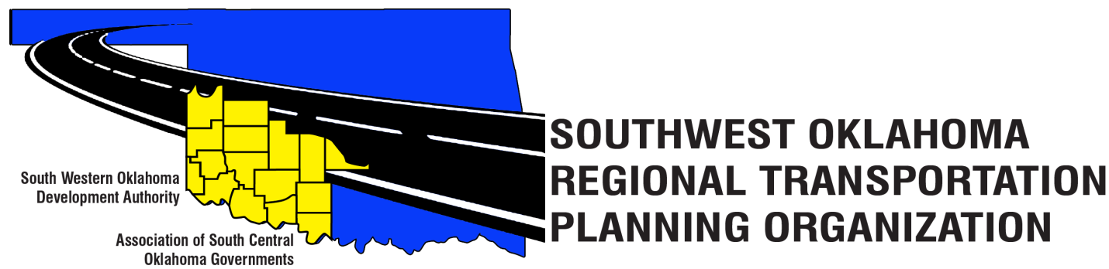

SORTPO Technical Committee

Meeting Agenda
April 13, 2017 10:00 a.m.
Western Technology Center  Adult Education Bldg,  621 Sooner Dr.  Burns Flat, OK 73624 | Red River Technology Center  JDM Business Center, Rm B113  3300 W. Bois D’Arc  Duncan, OK 73533
- Call to Order
- Roll Call – Introductions
- Approval of the minutes for the March 9, 2017 meeting.

- Discuss and consider recommending to the SORTPO Policy Board the following:
A. Discuss Goal categories and strategies for Cotton, Greer, Harmon, Jackson, Jefferson, Stephens, & Tillman County 2040 LRTP.
B. Key issues, trends, and challenges for Cotton, Greer, Harmon, Jackson, Jefferson, Stephens, & Tillman County 2040 LRTP.

5. Old Business

6. Reports and Comments-

7. Adjourn

