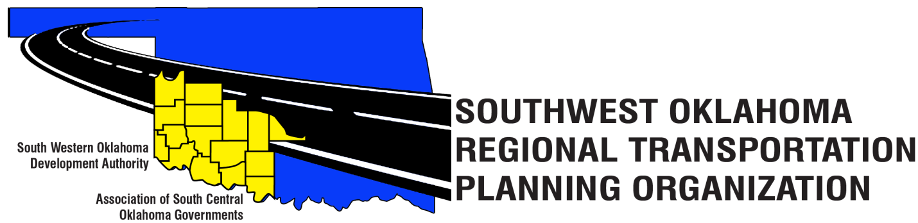
SORTPO Policy Board
Meeting Agenda
April 27, 2017 10:30 a.m.
Western Technology Center  Adult Education Bldg,  621 Sooner Dr.  Burns Flat, OK 73624 | Red River Technology Center  JDM Business Center, Rm B113  3300 W. Bois D’Arc  Duncan, OK 73533
- Call to Order

- Roll Call – Introductions

- Approval of the minutes for the March 23, 2017 meeting.

- Discuss and consider approving:

A. Goal categories and strategies for Cotton, Greer, Harmon, Jackson, Jefferson, Stephens, & Tillman County 2040 LRTP. (Attachment 1a- 1g)

B. Key issues, trends, and challenges for Cotton, Greer, Harmon, Jackson, Jefferson, Stephens, & Tillman County 2040 LRTP. (Attachment 2a- 2g)

- Old Business

- Reports and Comments

- Adjourn

