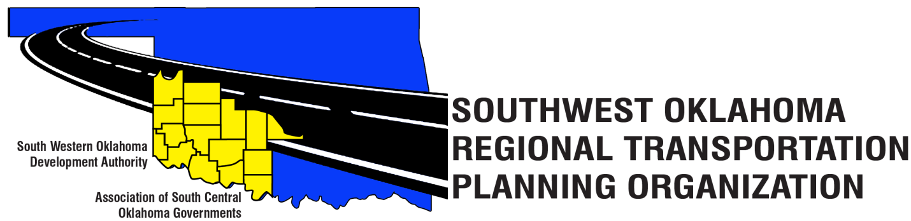
SORTPO Technical Committee

Meeting Agenda
May 18, 2017 10:00 a.m.
Western Technology Center  Adult Education Bldg,  621 Sooner Dr.  Burns Flat, OK 73624 | Red River Technology Center  JDM Business Center, Rm B113  3300 W. Bois D’Arc  Duncan, OK 73533
- Call to Order
- Roll Call – Introductions
- Approval of the minutes for the April 13, 2017 meeting.

- Discuss and provide comments to the SORTPO Policy Board the draft on the 2040 LRTP for Greer, Harmon, Jackson, Jefferson and Stephens Counties.
5. Old Business

6. Reports and Comments-

7. Adjourn

