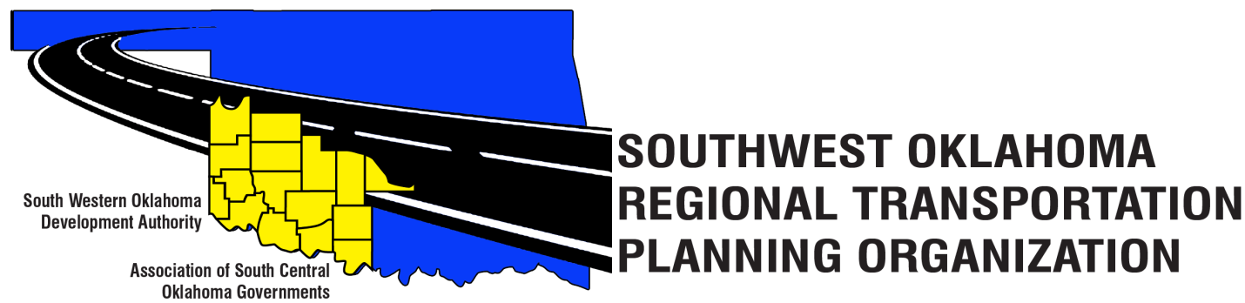

SORTPO

Technical Committee Minutes
June 15, 2017
10:00 a.m.
Western Technology Center | Red River Technology Center
Adult Education Bldg 621 Sooner Dr. | JDM Business Center, Rm B113
Burns Flat, OK 73624 | Duncan, OK 73533

Technical Committee Members | P/A | Technical Committee Members | P/A
Bryce Bohot | P | Jeff Morton | A
Elesia Church | P | Kevin Ouellette | A
Jana Harris | A | John Sheppard | P
Steve Kelly | P | Cole Vonfeldt | P
Lee Litterell | A | Basil Weatherly | P
Jim Mason | P
Others in attendance included: Becky Cockrell, SORTPO; Julie Sanders Consultant;

1. Call to Order:
The Technical Committee meeting was called to order by Becky Cockrell.
2. Roll Call – Introductions:
Becky Cockrell- quorum declared

3. Approval of Minutes:
The minutes of the April 13, 2017 meeting were reviewed. Motion was made by Jim Mason to approve minutes and seconded by Elesia Church, motion passed.

4. Discuss and provide comments to the SORPTO Policy Board on the draft 2040 LRTP for Greer, Harmon, Jackson, Jefferson, and Stephens Counties. Cockrell asked if the members were able to open the electronic file and print for review. Sanders summarized the contents of the LRTP chapters and advised that with the exception of information in Chapter 3 (Future Conditions) and Chapter 6 Transportation Recommendations the plans are nearing completion. Information in Chapter 3 to be finalized include: Traffic Analysis Zone (TAZ) maps and tables for Stephens and Jefferson Counties and major employers by TAZ. Staff is waiting for information from cities/counties/transit identifying future transportation projects and also the FFY 2017-2024 ODOT 8 Year Construction Program plan. Staff is waiting on this Plan to ensure that the most current information on projects will be identified due to cuts imposed by the State of Oklahoma’s FY 2017-2018 approved budget. Written comments on the draft plans are needed by July 24th. Receiving comments by this date allows staff to incorporate changes or respond to questions prior to finalizing the plans. Staff anticipates sending the final LRTPs for your review on August 2nd. The Technical Committee at their August 17th meeting will be asked to make a recommendation to the Transportation Policy Board to take action on the plans. The Transportation Policy Board at their August 24th meeting will consider the Committee’s recommendation on the Plans. At this meeting the Board will also consider scheduling a 30 day public review and comment period between August 28th-September 26th. Final approval of the 2040 LRTP for Greer, Harmon, Jackson, Jefferson and Stephens counties is anticipated on October 26th. Final approval of plans for Cotton and Tillman is anticipated in November – December.

5. Old Business:

6. Reports and Comments: Becky reported that ODOT has released the information for the TAP and Safe Route to School grants. Elesia Church commented on the process of the grant that you need to be starting now on the process of the application and lining up resources to better prepare you for getting the grant.

7. Adjourn:
Basil Weatherly moved adjournment, Bryce Bohot seconded.

