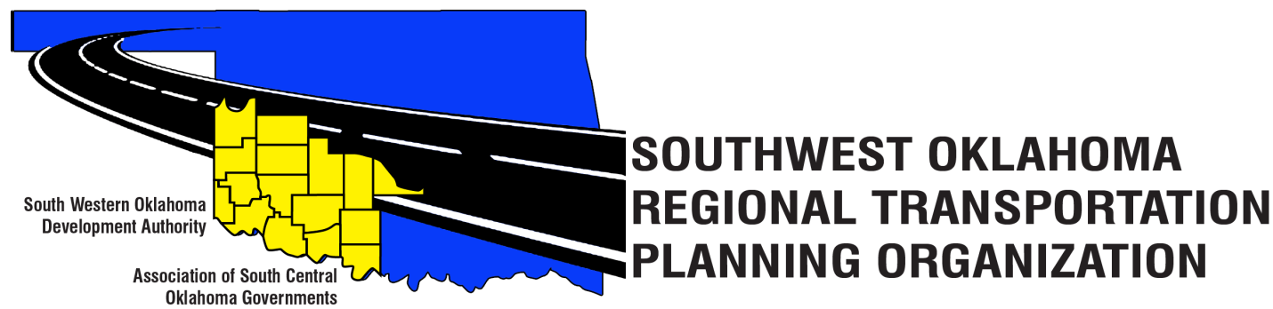
SORTPO Policy Board
Meeting Agenda
June 22, 2017 10:30 a.m.
Western Technology Center  Adult Education Bldg,  621 Sooner Dr.  Burns Flat, OK 73624 | Red River Technology Center  JDM Business Center, Rm B113  3300 W. Bois D’Arc  Duncan, OK 73533
- Call to Order
- Roll Call – Introductions
- Approval of the minutes for the April 27, 2017 meeting.
- Discuss comments provided by the SORPTO Transportation Technical Committee and comments by the Transportation Policy Board for the 2040 LRTP for Greer, Harmon, Jackson, Jefferson and Stephens Counties and provide direction to staff.

- Old Business

- Reports and Comments

- Adjourn

