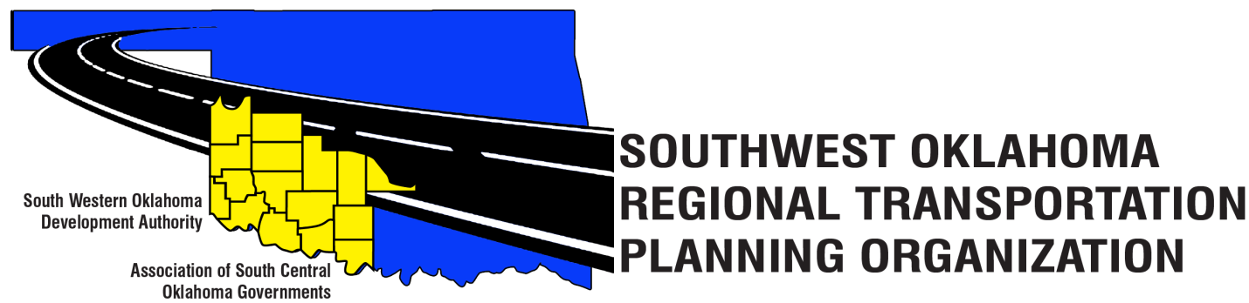
SORTPO Policy Board
Meeting Agenda
September 28, 2017 10:30 a.m.
Western Technology Center  Adult Education Bldg,  621 Sooner Dr.  Burns Flat, OK 73624 | Red River Technology Center  JDM Business Center, Rm B113  3300 W. Bois D’Arc  Duncan, OK 73533
- Call to Order
- Roll Call – Introductions
- Approval of the minutes for the August 24, 2017 meeting.
- Discuss and consider comment received on the 2040 LRTP’s during the public comments period.
  - 2040 Greer County Long Range Transportation Plan
  - 2040 Harmon County Long Range Transportation Plan
  - 2040 Jackson County Long Range Transportation Plan
  - 2040 Jefferson County Long Range Transportation Plan
  - 2040 Stephens County Long Range Transportation Plan

- Hold a public hearing and consider adopting by resolution the:
  - 2040 Greer County Long Range Transportation Plan
  - 2040 Harmon County Long Range Transportation Plan
  - 2040 Jackson County Long Range Transportation Plan
  - 2040 Jefferson County Long Range Transportation Plan
  - 2040 Stephens County Long Range Transportation Plan

- Discuss and consider approving the Transportation Planning Consultant Request for Proposal_____________________________
- Discuss and provide comments on the on the draft FFY 2017-2018 Planning Work Program.
- Discuss and consider approving amendment to the SORTPO Policy By-Laws Article III Membership to provide a designation of alternate.

- New Business.

- Reports and Comments.

- Adjourn.

