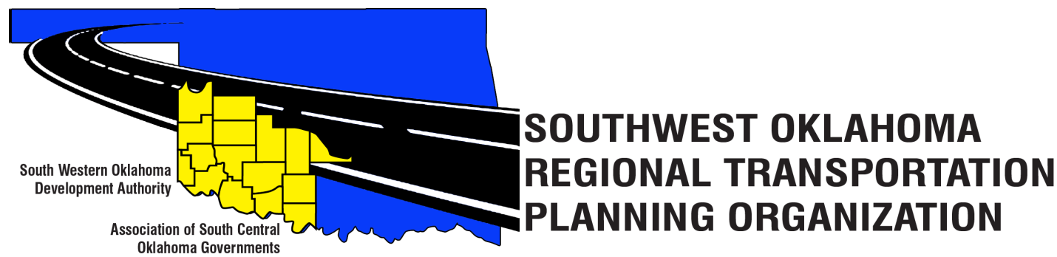
SORTPO Technical Committee

Meeting Agenda
September 28, 2017 10:30 a.m.
Western Technology Center  Adult Education Bldg,  621 Sooner Dr.  Burns Flat, OK 73624 | Red River Technology Center  JDM Business Center, Rm B113  3300 W. Bois D’Arc  Duncan, OK 73533
- Call to Order
- Roll Call – Introductions
- Approval of the minutes for the August 17, 2017 meeting.
- Discuss and consider comments received during the public review and comment period for LRTPs listed in 4A-E and forward comments to the SORTPO Transportation Policy Board.
  - 2040 Greer County Long Range Transportation Plan
  - 2040 Harmon County Long Range Transportation Plan
  - 2040 Jackson County Long Range Transportation Plan
  - 2040 Jefferson County Long Range Transportation Plan
  - 2040 Stephens County Long Range Transportation Plan

- Discuss and recommend to the SORTPO Transportation Policy Board approval of:
  - 2040 Greer County Long Range Transportation Plan
  - 2040 Harmon County Long Range Transportation Plan
  - 2040 Jackson County Long Range Transportation Plan
  - 2040 Jefferson County Long Range Transportation Plan
  - 2040 Stephens County Long Range Transportation Plan

- Discuss and recommend to the SORTPO Transportation Policy Board the Joint Certification Statement for the South West Oklahoma Regional Transportation Planning Organization regional transportation planning process by the Oklahoma Department of Transportation and SORTPO.

- Discuss and recommend to the SORTPO Policy Board approval of the transportation planning consultant request for proposals.
- Discuss and recommend to the SORTPO Policy Board the draft of the FFY 2017-2018 Planning Work Program.

- New Business.

- Reports and Comments.

- Adjourn

