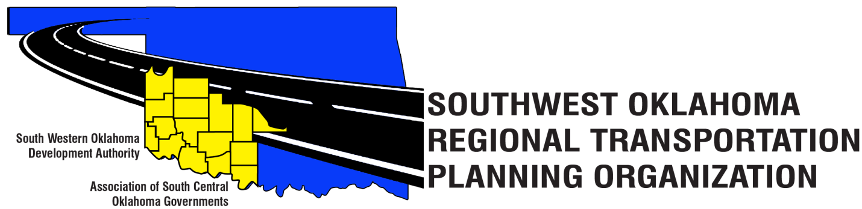

SORTPO

Technical Committee Minutes
August 17, 2017
10:00 a.m.
Western Technology Center | Red River Technology Center
Adult Education Bldg 621 Sooner Dr. | JDM Business Center, Rm B113
Burns Flat, OK 73624 | Duncan, OK 73533

Technical Committee Members | P/A | Technical Committee Members | P/A
Bryce Bohot | P | Jeff Morton | A
Elesia Church | A | Kevin Ouellette | P
Jana Harris | P | John Sheppard | P
Steve Kelly | P | Cole Vonfeldt | P
Lee Litterell | P | Basil Weatherly | P
Jim Mason | P | Mike Weixel | A
Others in attendance included: Becky Cockrell, SORTPO; Julie Sanders Consultant;

1. Call to Order:
The Technical Committee meeting was called to order by Jana Harris.
2. Roll Call – Introductions:
Becky Cockrell- quorum declared

3. Approval of Minutes:
The minutes of the June 15, 2017 meeting were reviewed. Motion was made by Basil Weatherly to approve minutes and seconded by Kevin Ouellette, motion passed.

4. Discuss and provide comments to the SORPTO Policy Board on the 2040 LRTP for Greer, Harmon, Jackson, Jefferson, and Stephens Counties. Sanders recommended that comments other than grammatical be identified and discussed today and asked that grammatical changes be sent to Becky Cockrell. Lisa L. and John S. asked that the Plans be sent in MS Word format for ease of editing.

5. Discuss and recommend to the SORTPO Policy Board establishing a 30-day public review and comment period (August 28, 2017- September 26, 2017) to solicit comments on the 2040 Long Range Transportation Plans for the Counties of Greer, Harmon, Jackson, Jefferson, and Stephens. Motion was made by Jim Mason and seconded by Lee Litterell.

6. Discuss and provide comments on the draft FFY 2017-2018 Planning Work Program to the SORTPO Policy Board. Jana discussed that SORTPO did not receive the SPR funding amounts from ODOT until after the PWP was distributed and this draft does not include a completed budget but would have it for the Policy Board to review. Motion was made by John Sheppard and seconded by Kevin Ouellette.

7. Discuss and provide recommendation to the SORTPO Policy Board on the Transportation Planning Consultant Request for Proposal.

Jana discussed with the Technical Committee Board that the current SPR funding agreement is between ODOT and the Oklahoma Association of Regional Councils (OARC). The current transportation planning consultant contract is with OARC. Beginning October 1, 2017, the new funding agreement is between ODOT and SORTPO. With this change in the SPR agreement it is necessary for SORTPO to advertise for transportation planning services to hire a consultant. Motion was made by Jim Mason and seconded by Basil Weatherly, Sheppard abstained.

8. Review and recommend to the SORTPO Policy Board for approval:
A. Memorandum of Understanding between SWODA/ ASCOG (SORTPO) and ODOT. Jana discussed with the Technical Committee that since OARC is no longer the recipient of the SPR funds for the RTPOs, SORTPO would of must sign MOU with ODOT. Motion was made by Jim Mason and seconded by Lee Litterell.
B. State Planning & Research (SPR) Funding Agreement between SORTPO and ODOT.
Jana discussed with the Technical Committee that since OARC is no longer the recipient of the SPR funds for the RTPOs, SORTPO would of must sign the SPR Funding Agreement. Motion was made by John Sheppard and seconded by Kevin Ouellette.

9. New Business.

10. Reports and Comments. Becky Cockrell reported that she will be starting her next two stakeholder’s meeting for Kiowa and Washita County in October 2017 and Steve Kelly will be starting on Caddo and McClain Counties.

11. Adjourn. Motion was made by Jim Mason and seconded by Basil Weatherly.

