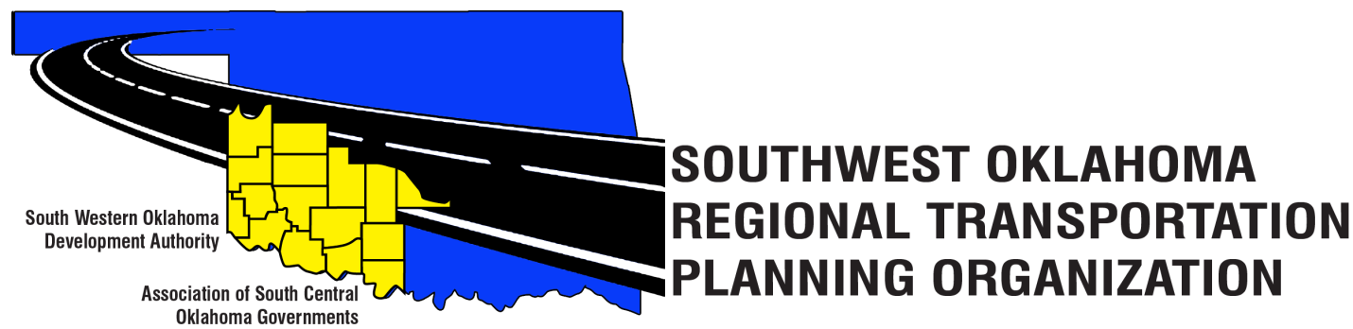

SORTPO

Technical Committee Minutes
Special Meeting
September 28, 2017
10:30 a.m.
Western Technology Center | Red River Technology Center
Adult Education Bldg 621 Sooner Dr. | JDM Business Center, Rm B113
Burns Flat, OK 73624 | Duncan, OK 73533

Technical Committee Members | P/A | Technical Committee Members | P/A
Bryce Bohot | P | Jeff Morton | A
Elesia Church | A | Kevin Ouellette | A
Becky Cockrell | P | John Sheppard | P
Jana Harris | A | Cole Vonfeldt | P
Steve Kelly | A | Basil Weatherly | P
Lee Litterell | A | Mike Weixel | A
Jim Mason | P
Others in attendance included: Julie Sanders Consultant;

1. Call to Order:
The Technical Committee meeting was called to order by Lyle Miller.
2. Roll Call – Introductions:
Becky Cockrell- quorum declared

3. Approval of Minutes:
The minutes of the August 17, 2017 meeting were reviewed. Motion was made by Jim Mason to approve minutes and seconded by Basil Weatherly, motion passed.

4. Discuss and consider comments received during the 30-day Public Review and Comment Period for the LRTP’S to the SORPTO Policy Board on the 2040 LRTP for Greer, Harmon, Jackson, Jefferson, and Stephens Counties. Comments received during the 30-day public review and comment period are included as Attachment A.

5. Discuss and recommend to the SORTPO Policy Board to approve the 2040 LRTPS for Greer, Harmon, Jackson, Jefferson and Stephens Counties.
Lyle Miller asked the Technical Committee if they had a motion to recommend the SORTPO Policy Board to approve the 2040 LRTP’s for Greer, Harmon, Jackson, Jefferson and Stephens Counties. Motion was made by John Sheppard and seconded by Jim Mason. Motion passed.

6. Discuss and provide recommendation to the SORTPO Policy Board on the Transportation Planning Consultant request for proposal. Tech. Committee did not have any comments.

7. Discuss and recommend to the SORTPO Policy Board the draft of the FFY 2017-2018 Planning Work Program and set a 10-day public review and comment period. Cockrell summarized changes to the PWP that were made since the August Policy Board Meeting. Changes include: final funding by Element, inclusion of development of the Limited English Proficiency Plan and minor grammatical corrections. Mrs. Sander’s stated that Mrs. Cockrell will put the Planning Work Program on the SORTPO website starting October 2, 2017 and will be on website for review and comments until October 13, 2017.

9. New Business.

10. Reports and Comments.
Becky Cockrell reported, stakeholder’s meeting for Kiowa and Washita Counties are scheduled: Kiowa County is on October 10, 2017 at 10:00 a.m. at the Western Technology Center in Hobart, Ok. Washita County is on October 17, 2017 at 10:00 a.m. at the Western Technology Center in Burns Flat, OK. Cockrell reminded the Technical Committee that October’s meeting is rescheduled from October 19th to October 12th at this meeting the Technical Committee will consider recommending to the SORTPO Policy Board to approve a 30 day public review and comment period for the 2040 Cotton and Tillman Counties LRTP. Cockrell also asked the Technical Committee to please write on your calendars a special meeting on November 30, 2017 to consider recommending to the SORTPO Policy Board to approve the 2040 LRTP’S for Cotton and Tillman Counties.

11. Adjourn. Motion was made by Jim Mason and seconded by Tom Zigler.

