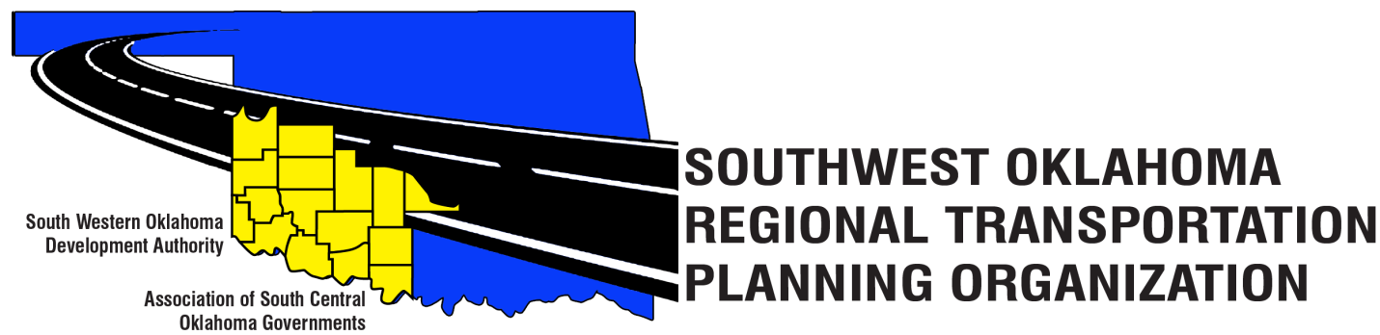
SORTPO Policy Board Committee

Special Meeting Agenda
November 30, 2017 10:30 a.m.
Western Technology Center  Adult Education Bldg,  621 Sooner Dr.  Burns Flat, OK 73624 | Red River Technology Center  JDM Business Center, Rm B113  3300 W. Bois D’Arc  Duncan, OK 73533
- Call to Order.
- Roll Call.
- Introduction of Guests.
- Approval of the minutes for the October 26, 2017 meeting.

5. Hold a public hearing to receive comments on the 2040 LRTP’s.
A. 2040 Cotton County Long Range Transportation Plan.
B. 2040 Tillman County Long Range Transportation Plan.

6. Discuss and consider adopting by resolution the:
A. 2040 Cotton County Long Range Transportation Plan.
B. 2040 Tillman County Long Range Transportation Plan.

7. Discuss and consider recommending to the South Western Oklahoma Development Authority Board of Trustees amendments of the SORTPO Policy Board By-laws.
  - Alternate
B. Meeting Attendance - (Board membership shall become vacant when a member is absent at any three consecutive regularly scheduled meetings.)
8. Reports and Comments.

9. Adjourn.

