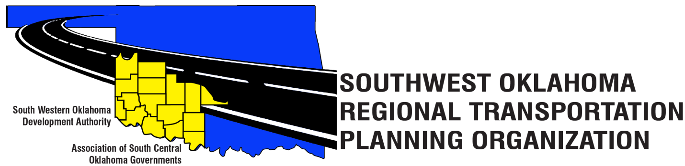
SORTPO Policy Board Committee

Special Meeting Agenda
October 26, 2017 10:30 a.m.
Western Technology Center  Adult Education Bldg,  621 Sooner Dr.  Burns Flat, OK 73624 | Red River Technology Center  JDM Business Center, Rm B113  3300 W. Bois D’Arc  Duncan, OK 73533
- Call to Order.
- Roll Call.
- Introduction of Guests.
- Approval of the minutes for the September 28, 2017 meeting.
- Discuss and consider appointment of Technical Committee Membership. (By-Laws Article VI)
Old Business

- Discuss and consider recommending to the South Western Oklahoma Development Authority Board of Trustees amendments of the SORTPO Policy Board By-laws.

  - Policy Board Membership-Alternate (By-Laws Article V)
  - Policy Board Membership-Meeting Attendance (By-Laws Article III)
(Board membership shall become vacant when a member is absent at any three consecutive regularly scheduled meetings.)
- Discuss and consider adopting Resolution 2017-6 and approving the FFY 2018 Planning Work Program (PWP).

New Business

- Discuss and consider establishing a 30-day public review and comment period (October 30, 2017 – November 28, 2017) for the 2040 Cotton County and 2040 Tillman County Long Range Transportation Plan.

- Discuss and approve the 2018 meeting schedule.

10. Reports and Comments.

11. Adjourn.

