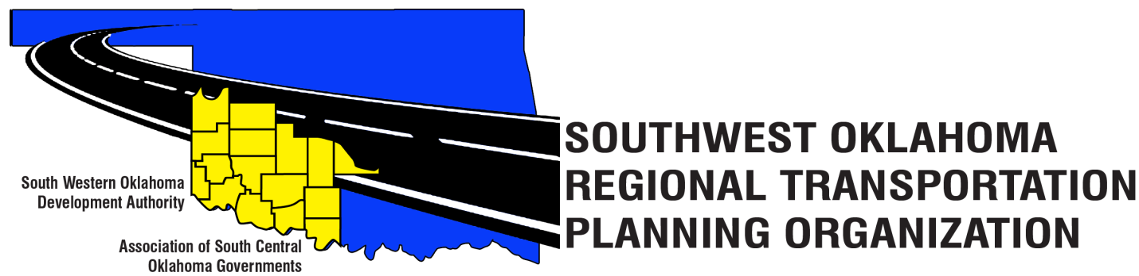

SORTPO

Policy Board Minutes
Special Meeting
October 26, 2017
10:30 a.m.
Western Technology Center | Red River Technology Center
Adult Education Bldg | JDM Business Center, Rm B113
Burns Flat, OK 73624 | Duncan, OK 73533

Policy Board Members | P/A | Policy Board Members | P/A
Brent Almquist | P | Lyle Miller | A
Anita Archer | P | Cendie Newman | P
Dale Bunn | A | Lyle Roggow | P
Kirk Butler | A | Heather Sheppard | P
Jerry Dean | P | Mark Skiles | P
Jay Earp | A | Clark Southard | P
Marilyn Feaver | A | Bill Spurlock | P
Shawn Freie | A | Larry Thoma | A
Mike Galloway | P | Tom Zigler | P
Debora Glasgow | P

Representing SORTPO:
Becky Cockrell, SORTPO
Julie Sanders, Consultant

1. Call to Order:
Meeting called to order at 10:32 a.m. by Anita Archer.
2. Roll Call – Introductions:
Becky Cockrell–quorum declared

3. Introduction of Guests.

4. Approval of Minutes:
The minutes of the September 28, 2017 meeting were presented. Anita Archer stated that Item 6 in the minutes regarding Julie Sanders contract total should be $130,000 not $139,500. Motion was made by Clark Southard and seconded by Bill Spurlock to accept Mrs. Sanders proposal subject to agreement by both parties that the total cost would not exceed $130,000.

Motion passed.

5. Discuss and consider appointment of Technical Committee Membership. ( By-Laws Article III).
Debora Glasgow stated that two Technical Committee members have not been able to attend the meetings this past year due to job duties. According to the SORTPO Policy Board By-Laws Article VIII “Committee are established by the board as necessary”. Motion was made by Jerry Dean and seconded by Debora Glasgow to remove Monty Proffitt and Mike Weixel from the Technical Committee.

Motion passed.

6. Discuss and consider recommending to the South Western Oklahoma Development Authority Board of Trustees amendments of the SORTPO Policy Board By-Laws.
A. Policy Board- Alternate
B. Policy Board -Meeting Attendance

Proxy and alternate voting was discussed at the September board meeting. Members were concerned about lack of a quorum at meetings and how it effects or delays meeting work requirements set forth by Oklahoma Department of Transportation. The board requested that additional information regarding this matter be presented at the October meeting.

Debora Glasgow presented information to the board regarding alternate or proxy voting. It was recommended that alternates be appointed for voting rather than proxy voting. Other items discussed regarding alternate voting were:
- Alternate can be used one time in as a yearly meeting schedule. “One-time alternate use.”
- Board members would not be required to appoint an alternate but the option is available to do so.
- Alternate should only be used in the event that the board members absence will prevent a quorum.

General discussion was also held regarding meeting attendance. It was noted once again that lack of attendance prevents business being conducted. Recommendation was made for board members to review the attendance record presented by Ms. Cockrell. Board members should be prepared at next meeting to make recommendations on who should serve and who should not.

By-law amendments were tabled until next meeting.

7. Discuss and consider adopting Resolution 2017-6 and approving the FFY 2018 Planning Work Program (PWP).
Becky Cockrell stated that the Technical Committee recommended to the Policy Board to approve the 2017-6 Resolution and to adopt the FFY 2018 Planning Work Program (PWP). Motion was made by Bill Spurlock and seconded by Clark Southard to approve Resolution 2017-6 and adopt FFY 2018 PWP.

Motion passed.

New Business

8. Discuss and consider establishing a 30-day public review and comment period (October 30, 2017 – November 28, 2017) for the 2040 Cotton County and 2040 Tillman County Long Range Transportation Plan.
Motion was made by Mark Skiles and seconded by Jerry Dean to set the 30-day public comment period as presented.

Motion passed.

9. Discuss and approve the 2018 meeting Schedule
Motion was made by Jerry Dean and seconded by Bill Spurlock to approve the 2018 meeting schedule.

Motion passed.

10. Reports and Comments:
Becky Cockrell reported that she had completed stakeholder’s meeting for Kiowa and Washita Counties. Cockrell reported that at the Kiowa County stakeholders meeting on October 10th 11 people attended. She was asked to speak at the Kiowa County Health Coalition Group meeting on Oct. 16th and 5 people attended the meeting. The Kiowa County Health Coalition invited Mrs. Cockrell to prepare a 1 minute radio audio summarizing the LRTP and survey to be aired the week of November 14th. The Washita County stakeholders meeting was held on October 17th and 8 people attended.

Tom Zigler reported that on October 4, 2017 we had a RTPO meeting with ODOT and went over the Transportation Alternative Program (TAP) grant grading questions. The RTPO’s have gone through one round of questions that will be on the application and ODOT will have another meeting on November 1st. Lisa Lam with ODOT reported that the RTPO’s will discuss some more scoring questions in regards to TAP grant. Lisa Lam stated that Chad Meisenburg with ODOT will also meet with a couple of the MPO’s (ACOG and INCOG) to discuss some scoring questions and will compile all questions between the RTPO’s and MPO’s and have the final scoring questions.

Mr. Zigler also announced McClain County stakeholders meeting will be on November 14, 2017 at Wayne, Oklahoma and the Grady County stakeholders meeting will be on November 28, 2017 at Chickasha, Oklahoma.

11. Adjourn.
Motion made by Bill Spurlock and seconded by Brent Almquist.

ATTEST:

___________________________ _________________________
(Chairman) (Secretary)

