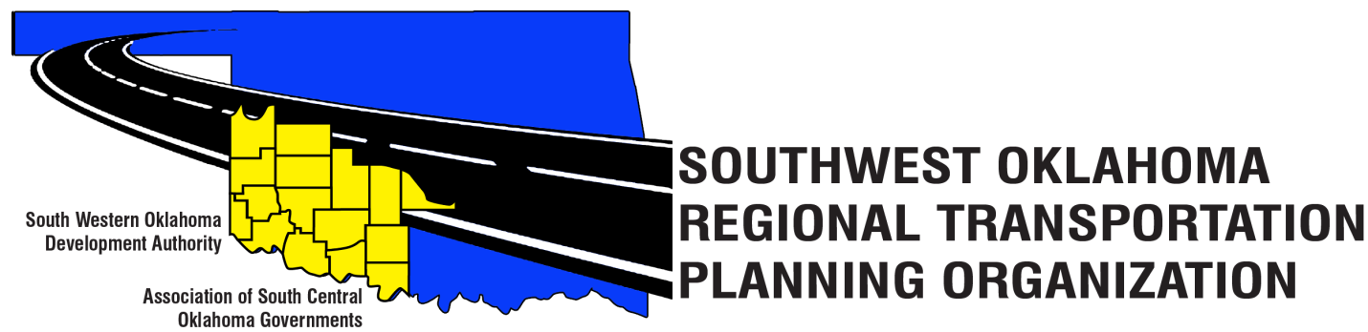

SORTPO

Policy Board Minutes
Special Meeting
September 28, 2017
10:30 a.m.
Western Technology Center | Red River Technology Center
Adult Education Bldg | JDM Business Center, Rm B113
Burns Flat, OK 73624 | Duncan, OK 73533

Policy Board Members | P/A | Policy Board Members | P/A
Brent Almquist | P | Debora Glasgow | P
Anita Archer | P | Lyle Miller | P
Dale Bunn | A | Cendie Newman | P
Kirk Butler | P | Lyle Roggow | A
Jerry Dean | P | Heather Sheppard | P
Jay Earp | A | Mark Skiles | A
Marilyn Feaver | P | Clark Southard | P
Shawn Freie | A | Bill Spurlock | P
Mike Galloway | P | Larry Thoma | A
 |  | Tom Zigler | P
Others in attendance included: Becky Cockrell, SORTPO, Julie Sanders, Consultant

1. Call to Order:
Meeting called to order at 10:32 a.m. by Lyle Miller.
2. Roll Call – Introductions:
Becky Cockrell–quorum declared

3. Approval of Minutes:
The minutes of the August 24, 2017 meeting were discussed. Motion was made by Clark Southard to approve minutes and seconded by Tom Zigler, motion passed.

4. Discuss comments provided by the SORTPO Technical Committee on the public review and comment period for the 2040 LRTP for Greer, Harmon, Jackson, Jefferson and Stephens Counties. Comments received during the 30-day public review and comment period are included as Attachment A. Policy Board accepted the comments.

5. Discuss and consider the public hearing and consider adopting by resolution the:
A. 2040 Greer County Long Range Transportation Plan include Resolution Number - 2017-1
B. 2040 Harmon County Long Range Transportation Plan include Resolution Number- 2017-2
C. 2040 Jackson County Long Range Transportation Plan include Resolution Number- 2017-3
D. 2040 Jefferson County Long Range Transportation Plan include Resolution Number- 2017-4
E. 2040 Stephens County Long Range Transportation Plan include Resolution Number- 2017-5
Motion was made by Mr. Dean to approve the Greer, Harmon, Jackson, Jefferson, and Stephens Counties LRTPs and Stephens LRTP’S by Resolution was seconded by Mr. Southard. Motion Passed.

6. Discuss and consider approving the Transportation Planning Consultant Request for Proposal.
Mr. Dean had questions on the following: why do we need a consultant, how long will we need a consultant and the cost of Mrs. Sander proposal to do the contract work. Mrs. Glasgow stated that Mrs. Cockrell had only been with us for almost 2 years and that there is a lot information in completing these plans. Mrs. Sanders has a degree in planning. Mrs. Glasgow commented on the question how long SORTPO will need a consultant? We do not know until the SORTPO staff feels confident in completing the plans. Mr. Zigler commented how ODOT has several consultants to help them with their Statewide Transportation Plans. Mrs. Cockrell comment on that she does not feel comfortable yet without Mrs. Sander’s assistance. Mrs. Cockrell expressed her concerns in regards to her name being on the plans and she shows great pride in completing a plan correctly. Mrs. Cockrell also commented on the cost of Mrs. Sander’s proposal is higher than last year’s proposal and the reason for the cost is the plans for Cotton and Tillman County that should have been completed in the FFY 2017. Motion was made by Mr. Southard to accept Mrs. Sanders Proposal subject to agreement by both parties that the total cost would not exceed $130,000.00 and seconded by Mr. Zigler. Motion Passed.

7. Discuss and provide comments on the draft FFY 2017-2018 Planning Work Program and set a 10-day public review and comment period. Cockrell summarized changes to the PWP that were made since the August Policy Board Meeting. Changes include: final funding by Element, inclusion of development of the Limited English Proficiency Plan and minor grammatical corrections. Mrs. Sander’s stated that Mrs. Cockrell will put the Planning Work Program on the SORTPO website starting October 2, 2017 and will be on website for review and comments until October 13, 2017.

8. Discuss and consider approving to the SORTPO Policy By- Laws Article III Membership to provide a designation of alternate. The Policy Board discussed Membership and voting privileges. Jerry Dean did not see the need for an alternate, Clark Southard commented that if a member misses 3 consecutive meeting the person is removed from the Board and allowing each Board member one proxy vote per year. Heather Sheppard commented that the one proxy vote should be limited to when there is not a quorum. Marilyn Feaver asked that an attendance chart be developed and sent to the Policy Board with agenda and minutes. The Policy Board agreed to table discussion until the October meeting to give some more thoughts how to proceed.

9. New Business:
Mr. Southard reported the Oklahoma Airport Operators Association plans will be available on the Oklahoma Aeronautics Commission website. The plans will provide economic impact on the communities and state.

10. Reports and Comments:
Becky Cockrell reported, stakeholder’s meeting for Kiowa and Washita Counties are scheduled: Kiowa County is on October 10, 2017 at 10:00 a.m. at the Western Technology Center in Hobart, Ok. Washita County is on October 17, 2017 at 10:00 a.m. at the Western Technology Center in Burns Flat, OK. Cockrell also asked the Board to please write on your calendars a special meeting on October 26th and November 30, 2017 to consider approving the 2040 LRTPS for Cotton and Tillman Counties.

11. Adjourn.
Motion made by Jim Mason and seconded by Tom Zigler.

ATTEST:

___________________________ _________________________
(Chairman) (Secretary)

