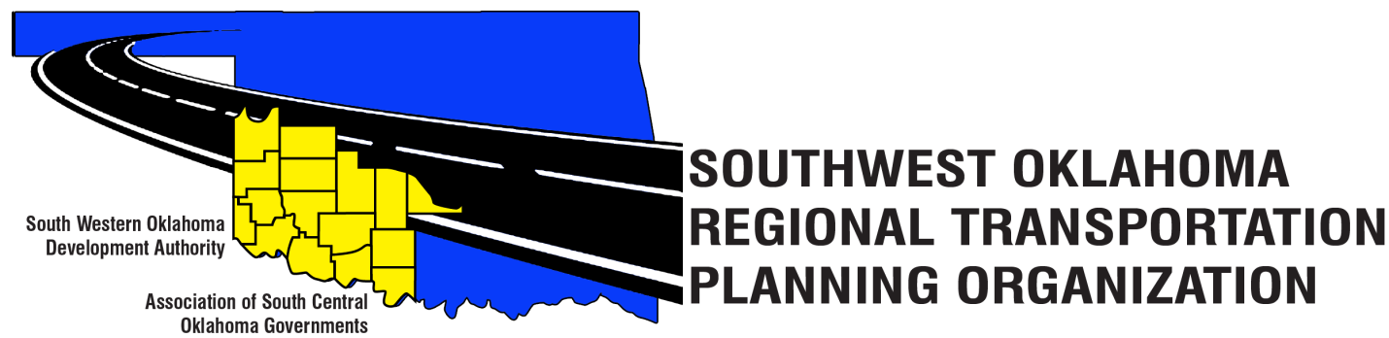
SORTPO Technical Committee

Special Meeting Agenda
October 26, 2017 10:30 a.m.
Western Technology Center  Adult Education Bldg,  621 Sooner Dr.  Burns Flat, OK 73624 | Red River Technology Center  JDM Business Center, Rm B113  3300 W. Bois D’Arc  Duncan, OK 73533
- Call to Order.
- Roll Call – Introductions.
- Introduction of Guests.
- Approval of the minutes for the September 28, 2017 meeting.
Old Business
- Discuss and recommend to the SORTPO Policy Board approval of the FFY 2018 Planning Work Program (PWP).

New Business.

- Discuss and recommend to the SORTPO Policy Board establishing a 30-day public review and comment period (October 30, 2017 – November 28, 2017) for the 2040 Cotton County and 2040 Tillman County Long Range Transportation Plans.

- Discuss and recommend to the SORTPO Policy Board the 2018 schedule of meetings.

- Reports and Comments.

- Adjourn.

