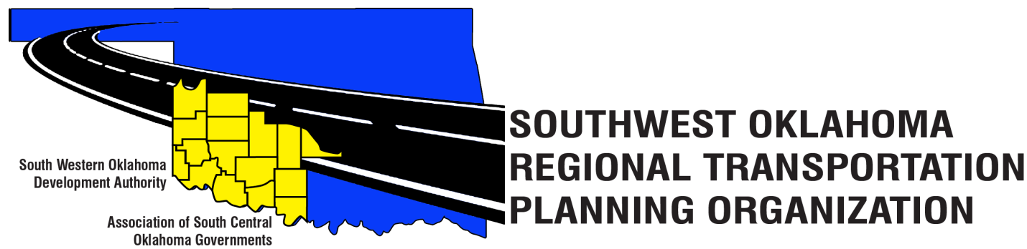
SORTPO Technical Committee

Special Meeting Agenda
November 30, 2017 10:00 a.m.
Western Technology Center  Adult Education Bldg,  621 Sooner Dr.  Burns Flat, OK 73624 | Red River Technology Center  JDM Business Center, Rm B113  3300 W. Bois D’Arc  Duncan, OK 73533
- Call to Order.
- Roll Call – Introductions.
- Introduction of Guests.
- Approval of the minutes for the October 26, 2017 meeting.
New Business.

- Discuss and consider comments received during public review and comment period for LRTP’s and forward comments to the SORTPO Policy Board.
A. 2040 Cotton County Long Range Transportation Plan.
B. 2040 Tillman County Long Range Transportation Plan.

- Discuss and recommend to the SORTPO Policy Board approval of:
A. 2040 Cotton County Long Range Transportation Plan.
B. 2040 Tillman County Long Range Transportation Plan.

- Reports and Comments.

- Adjourn.

