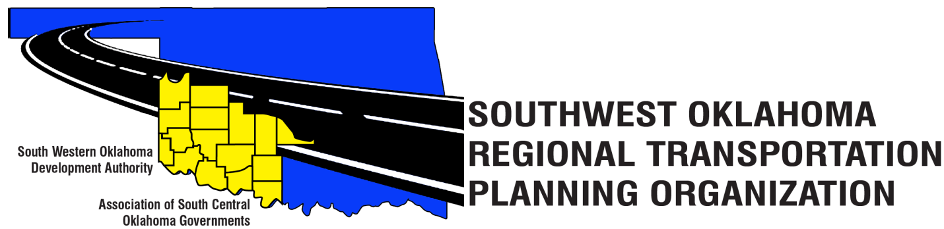
SORTPO Policy Board Committee
January 25, 2018, 10:30 a.m.
Final Agenda

Amended
January 23, 2018, 2:00 p.m.
Western Technology Center  Adult Education Bldg,  621 Sooner Dr.  Burns Flat, OK 73624 | Red River Technology Center  JDM Business Center, Rm B113  3300 W. Bois D’Arc  Duncan, OK 73533

- Call to Order

- Roll Call

- Introduction of Guests

- Approval of the minutes for the November 30, 2017 special meeting.

5. Discuss and consider appointing New Members to the SORTPO Technical Committee. Existing Members are identified in Table 1.

A. Larry Adler- Hobart City Manager- Kiowa County
B. Danny Britton- Business Director for Western Technology Center –Washita County

6. Review comments from the Technical Committee and provide direction to the staff on the following:

A. Attachment A - Grady County – Trends, issues, concern, goals, strategies and future population. (pg. 1-8)
B. Attachment B - Kiowa County- Trends, issues, concerns, goals, strategies and future population. (pg.9-15)
C. Attachment C - McClain County- Trends, issues, concerns, goals, strategies and future population. (pg. 16-23)
D. Attachment D - Washita County- Trends, issues, concerns, goals, strategies and future population. (pg. 24-29)

7. Old Business
8. New Business
9. Reports and Comments
10. Adjourn

