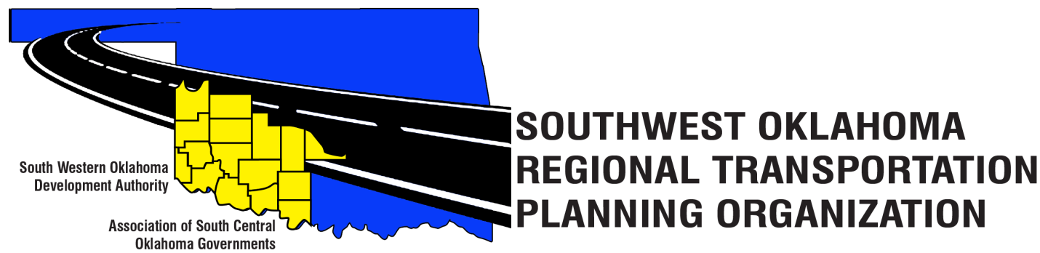
SORTPO Technical Committee
February 15, 2018 10:00 a.m.
Final Agenda
Amended
February 13, 2018 9:21 a.m.

Western Technology Center  Adult Education Bldg,  621 Sooner Dr.  Burns Flat, OK 73624 | Red River Technology Center  JDM Business Center, Rm B113  3300 W. Bois D’Arc  Duncan, OK 73533

1. Call to Order
2. Roll Call
3. Introduction of Guests
4. Approval of the minutes for the January 18, 2018 meeting.
Old Business
5. Discuss and provide comments to the SORTPO Policy Board on drafts:
- Chapters 1 and 2 of the 2040 Grady County LRTP
- Chapters 1 and 2 of the 2040 Kiowa County LRTP
- Chapters 1 and 2 of the 2040 McClain County LRTP
- Chapters 1 and 2 of the 2040 Washita Counties LRTP
New Business
6. Reports and Comments.
7. Adjourn.

