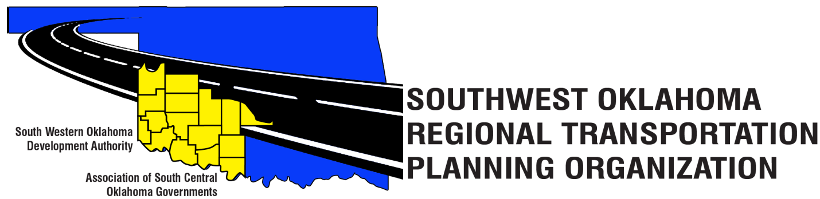

SORTPO Policy Board

Agenda

March 29, 2018, 10:30 a.m.
Western Technology Center  Adult Education Bldg,  621 Sooner Dr.  Burns Flat, OK 73624 | Red River Technology Center  JDM Business Center, Rm B113  3300 W. Bois D’Arc  Duncan, OK 73533

- Call to Order
- Roll Call
- Introduction of Guests
- Approval of the minutes for the January 25, 2018 meeting
5. Old Business

6. Discuss and consider approving 2040 population and employment projects for the following:

  - 2040 Grady County LRTP
  - 2040 Kiowa County LRTP
  - 2040 McClain County LRTP
  - 2040 Washita County LRTP

7. Discuss and review comments from the Technical Committee and provide direction to the staff on the following:

A. Chapters 1 and 2 of the 2040 Grady County LRTP
B. Chapters 1 and 2 of the 2040 Kiowa County LRTP
C. Chapters 1 and 2 of the 2040 McClain County LRTP
D. Chapters 1 and 2 of the 2040 Washita County LRTP

8. New Business

9. Discuss and consider new appointments to the SORTPO Policy Board.

A. Kevin Bloss – ODOT Division 3 Engineer
B. Tim Binghom- Kiowa County Commissioner
C. Sandy Settle- Washita County Emergency Manager

10. Reports and Comments
11. Adjourn

