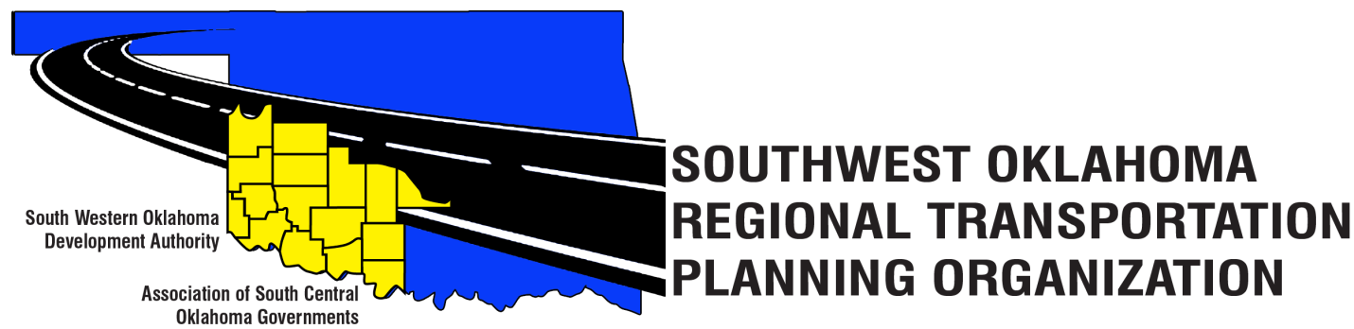
SORTPO Technical Committee
Agenda
April 19, 2018 10:00 a.m.

Western Technology Center  Adult Education Bldg,  621 Sooner Dr.  Burns Flat, OK 73624 | Red River Technology Center  JDM Business Center, Rm B113  3300 W. Bois D’Arc  Duncan, OK 73533

1. Call to Order.
2. Roll Call.
3. Introduction of Guests.
4. Approval of the minutes for the February 15, 2018 meeting.
5. Old Business.
6. New Business.
7. Discuss, provide comments and consider recommending to the SORTPO Policy Board approval of Amendment 1 to the FFY 2017-2018 Planning Work Program (PWP).
8. Discuss, provide comments and consider recommending to the SORTPO Policy Board approval of Amendment #2 to the Public Participation Plan (PPP).
9. Discuss, provide comments, and consider recommending to the SORTPO Policy Board approval of the Limited English Proficiency (LEP).
10. Reports and Comments.
11. Adjourn.

