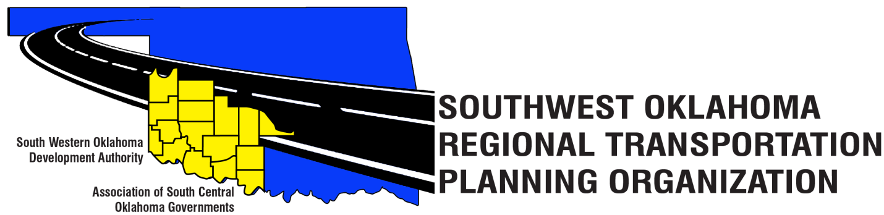

SORTPO

Technical Committee Minutes
April 19, 2018
10:00 a.m.
Western Technology Center | Red River Technology Center
Adult Education Bldg 621 Sooner Dr. | JDM Business Center, Rm B113
Burns Flat, OK 73624 | Duncan, OK 73533

Technical Committee Members | P/A | Technical Committee Members | P/A
Larry Adler | P | Jim Mason | A
Bryce Bohot | A | Kevin Ouellette | A
Elesia Church | P | John Sheppard | P
Becky Cockrell | P | Cole Vonfeldt | P
Steve Kelly | A | Basil Weatherly | P
Lee Litterell | P

Representing SORTPO:
Julie Sanders Consultant, Shelby Templin ODOT RTPO Coordinator

1. Call to Order:
Meeting called to order by Becky Cockrell, SORTPO Director.
2. Roll Call – Introductions:
Becky Cockrell, SORTPO Director - quorum declared

3. Introduction of Guests
Susan Featherston, Director of Finance

4. Approval of Minutes:

Motion to approve meeting minutes for the February 15, 2018 was made by John Sheppard and second by Cole Vonfeldt.

Motion Passed

5. Old Business
None

6. New Business
None

7. Discuss, provide comments and consider recommending to the SORTPO Policy Board approval of Amendment 1 to the FFY 2017-2018 Planning Work Program (PWP).

Motion was made by Cole Vonfeldt and seconded by John Sheppard for recommending approval to the SORTPO Policy Board for Amendment 1 to the Planning Work Program (PWP) to move funds to pay for GIS mapping consultants of Landlocked.

Motion passed.

8. Discuss, provide comments and consider recommending to the SORTPO Policy Board approval of Amendment #2 to the Public Participation Plan (PPP).

Motion was made by Lee Litterell and seconded by Larry Adler for recommending approval to the SORTPO Policy Board for Amendment 2 to the Public Participation Plan (PPP) to add changes that are required by ODOT.

Motion Passed.

9. Discuss, provide comments, and consider recommending to the SORTPO Policy Board approval of the Limited English Proficiency (LEP).

Motion was made by Cole Vonfeldt and seconded by Basil Weatherly for recommending to the SORTPO Policy Board for approval to the Limited English Proficiency (LEP).

Motion Passed.

10. Reports and comments

Shelby Templin with ODOT reported that she would be attending American Planning Association Conference in Regional and Small Communities’ sessions if she has any information of interested she would share at the next meeting. Becky Cockrell reported that the next Tech. Committee meeting would be moved up a week to May 10, 2018. Mrs. Cockrell reported that she needs some assistance in how to receive more survey’s for Kiowa County.

ATTEST:

__________________________________
(Chairman)

