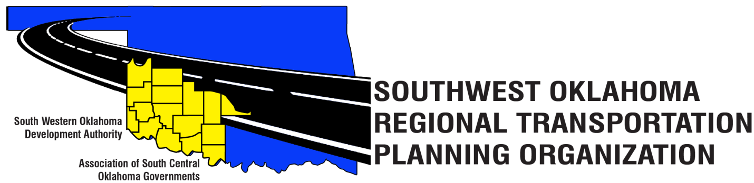

SORTPO Policy Board

Agenda

April 26, 2018, 10:30 a.m.
Western Technology Center  Adult Education Bldg,  621 Sooner Dr.  Burns Flat, OK 73624 | Red River Technology Center  JDM Business Center, Rm B113  3300 W. Bois D’Arc  Duncan, OK 73533

- Call to Order.
- Roll Call.
- Introduction of Guests.
- Approval of the minutes for the March 29, 2018 meeting.
- Old Business.
- New Business.
- Discuss and consider adopting Resolution #2018-1 approving Amendment #1 to the FFY 2017-2018 Planning Work Program (PWP).
- Discuss and consider setting a 45-day public and review comment period (April 30, 2018 – June 13, 2018) prior to adopting Amendment #2 to the Public Participation Plan (PPP).
- Discuss and consider setting a 10-day public review and comment period (June 4, 2018 – June 13, 2018) prior to the adoption of the Limited English Proficiency Plan (LEP).
- Reports and Comments.
- Adjourn

