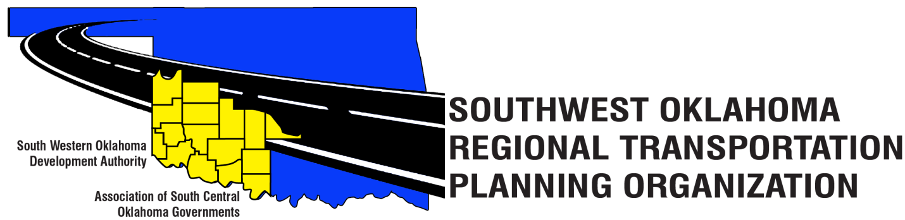

SORTPO

Policy Board Minutes
March 29, 2018
10:30 a.m.
Western Technology Center | Red River Technology Center
Adult Education Bldg | JDM Business Center, Rm B113
Burns Flat, OK 73624 | Duncan, OK 73533

Policy Board Members | P/A | Policy Board Members | P/A
Brent Almquist | P | Lyle Miller | A
Anita Archer | P | Cendie Newman | A
Dale Bunn | P | Lyle Roggow | P
Kirk Butler | A | Heather Sheppard | P
Jerry Dean | A | Mark Skiles | P
Jay Earp | P | Clark Southard | A
Marilyn Feaver | P | Bill Spurlock | P
Shawn Freie | A | Larry Thoma | A
Mike Galloway | A | Tom Zigler | P
Debora Glasgow | P

Representing SORTPO:
Becky Cockrell, SORTPO Director
Shelby Templin, ODOT RTPO Coordinator
Lisa Lam, ODOT

1. Call to Order:
Meeting called to order at 10:35 a.m. by Chairman Anita Archer.
2. Roll Call – Introductions:
Becky Cockrell, SORTPO Director – quorum declared

3. Introduction of Guests.
Sandy Settle- Washita County Emergency Management

4. Approval of Minutes:
Motion to approve meeting minutes from January 25, 2018 meeting was made by Bill Spurlock and second by Tom Zigler.

Motion passed.

5. Old Business - N/A

6. Discuss and consider approving 2040 population and employment projections for Grady, Kiowa, McClain and Washita Counties.
Discussion was made by the Policy Board considering Table1. Policy Board approved the 2040 population and employment projections. Motion was made by Bill Spurlock and seconded by Tom Zigler.
Motion passed.

Table 1: 2040 Population and Employment Projections
 | 2040 Population Projection | 2040 Employment Projection
Grady County | 67,356 | 31,367
Kiowa County | 9,426 | 4,702
McClain County | 47,203 | 30,749
Washita County | 11,861 | 5,048

7. Discuss and review comments from the Technical Committee and provide direction to the staff on the following:

A. Chapters 1 and 2 of the 2040 Grady County LRTP Discussion only
B. Chapters 1 and 2 of the 2040 Kiowa County LRTP Discussion only
C. Chapters 1 and 2 of the 2040 McClain County LRTP Discussion only
D. Chapters 1 and 2 of the 2040 Washita County LRTP Discussion only

8. New Business – N/A

9. Discuss and consider appointing New Members to the SORTPO Policy Board.
Motion was made to appoint Kevin Bloss, Tim Binghom, and Sandy Settle to the Policy Board.
Motion was made by Debora Glasgow and seconded by Bill Spurlock.

Motion Passed.

10. Reports and Comments:
- Tom Zigler, ASCOG- reported on the Grady Health Coalition Meeting on March 28, 2018 at the Canadian Valley Technology Center, Chickasha, OK.
- Lisa Lam, ODOT Local Government Division- reported on the updates for the TAP projects for McClain, Beckham, Custer, Kiowa, Washita, Caddo, Comanche, Grady and Stephens County.
- Becky Cockrell, SWODA- reported that the next Policy Board meeting will be on April 26, 2018.

11. Adjourn.
Motion to adjourn meeting was made by Tom Zigler and seconded by Mark Skiles.

Motion passed.

ATTEST:

___________________________ _________________________
(Chairman) (Secretary)

