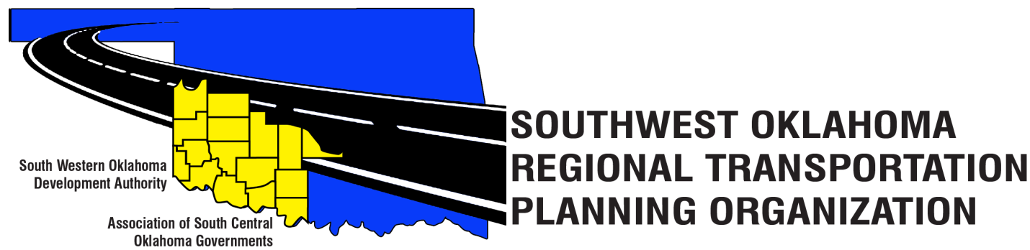

SORTPO Policy Board

Agenda

June 28, 2018, 10:30 a.m.
Western Technology Center  Adult Education Bldg,  621 Sooner Dr.  Burns Flat, OK 73624 | Red River Technology Center  JDM Business Center, Rm B113  3300 W. Bois D’Arc  Duncan, OK 73533

- Call to Order.
- Roll Call.
- Introduction of Guests.
- Approval of the minutes for the April 26, 2018 meeting.
- Old Business.
- Discuss, provide comment and consider adopting Resolution#2018-2 and approving Amendment #2 to the Public Participation Plan (PPP).

- Discuss, provide comment and consider adopting Resolution#2018-3 approving the Limited English Proficiency Plan (LEP).

- New Business.
  - Discuss and consider canceling the August 23rd meeting and scheduling a special meeting August 30th.

- Reports and Comments.
- Adjourn.

