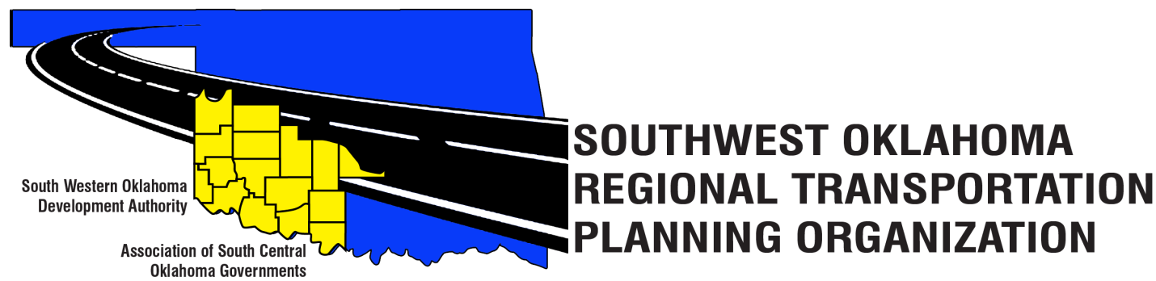
SORTPO Technical Committee
Agenda
June 21, 2018 10:00 a.m.

Western Technology Center  Adult Education Bldg,  621 Sooner Dr.  Burns Flat, OK 73624 | Red River Technology Center  JDM Business Center, Rm B113  3300 W. Bois D’Arc  Duncan, OK 73533

1. Call to Order.
2. Roll Call.
3. Introduction of Guests.
4. Approval of the minutes for the April 19, 2018 meeting.
5. Old Business.
6. Discuss, provide comments and consider recommending to the SORTPO Policy Board adoption of Resolution#2018-2 approving Amendment #2 to the Public Participation Plan (PPP).
7. Discuss, provide comments, and consider recommending to the SORTPO Policy Board adoption of Resolution#2018-3 approving the Limited English Proficiency (LEP).
8. New Business.
9. Reports and Comments.
10. Adjourn.

