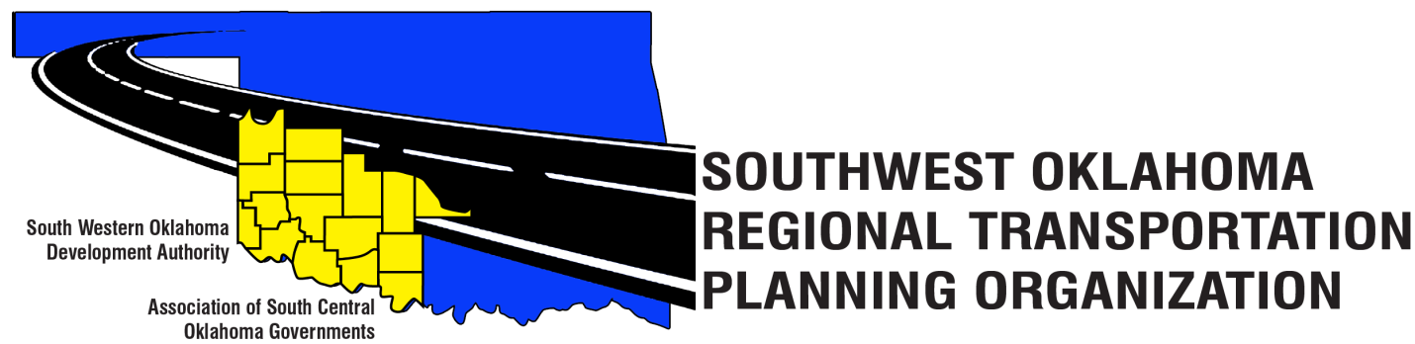

SORTPO

Technical Committee Minutes
June 21, 2018
10:00 a.m.
Western Technology Center | Red River Technology Center
Adult Education Bldg 621 Sooner Dr. | JDM Business Center, Rm B113
Burns Flat, OK 73624 | Duncan, OK 73533

Technical Committee Members | P/A | Technical Committee Members | P/A
Larry Adler | A | Jim Mason | P
Bryce Bohot | P | Kevin Ouellette | A
Elesia Church | P | John Sheppard | P
Becky Cockrell | A | Cole Vonfeldt | P
Steve Kelly | P | Basil Weatherly | P
Lee Litterell | P

Representing SORTPO:
Julie Sanders Consultant; Shelby Templin ODOT RTPO Coordinator

1. Call to Order:
Meeting called to order by Steve Kelly, ASCOG CED Planner
2. Roll Call – Introductions:
Amy Crowe, SWODA - quorum declared

3. Introduction of Guests
No guest at this meeting.

4. Approval of Minutes:

Motion to approve meeting minutes for the April 19, 2018 was made by John Sheppard and second by Lee Litterell.

Motion Passed

5. Old Business
Lee Litterelll inquired on whether legal counsel for committee members and SORTPO documents has been obtained. Committee members agreed to the need for legal counsel and would like to have this issue addressed by the Policy Board Committee.

6. Discuss, provide comments and consider recommending to the SORTPO Policy Board adoption of Resolution #2018-2 approving Amendment #2 to the Public Participation Plan (PPP).

Motion to approve changes presented and noted in the Amendment #2 to the Public Participation Plan (PPP) was made by Jim Mason and second by John Sheppard.

Motion passed.

Motion was made by Cole Vonfeldt and second by Elesia Church for recommending the adoption of Resolution #2018-2 approving Amendment #2 to the Public Participation Plan (PPP) once changes referred to above are made.

Motion passed

7. Discuss, provide comments and consider recommending to the SORTPO Policy Board adoption of Resolution# 2018-3 approving the Limited English Proficiency (LEP).

It was brought to attention that page 1 has a minor formatting error; committee asked for this correction to be made.

Motion to recommend SORTPO Policy Board to adopt Resolution# 2018-3; approving the Limited English Proficiency (LEP) with consideration of formatting error correction; motion made by Lee Litterell and seconded by Elesia Church.

Motion Passed

8. New Business.
Shelby Templin, ODOT
- Reminded members that the due date for the SORTPO PWP is August 1st, 2018.
- Census 2020 - the new geographical break down will be smaller than prior, counties need to contact the Census Bureau with their correct geographical boundaries.
- TAP – approved and will go live July 1st, 2018; application period Oct1st – Nov 30th – send applications directly to Shelby Templin, ODOT. Awards will be announced on March 4th, 2019.
Julie Sanders, Consultant
- Reminded the Committee that there will not be a meeting in July.
- Due to mapping delays the new tentative deadline for the final LEP & PPP is October 31st, 2018; with contingences of special meetings being held in September.

9. Reports and comments.
None to report

10. Adjourn
Motion to adjourn was made by Lee Litterell and second by Jim Mason.

Motion passed

ATTEST:

__________________________________
(Chairman)

