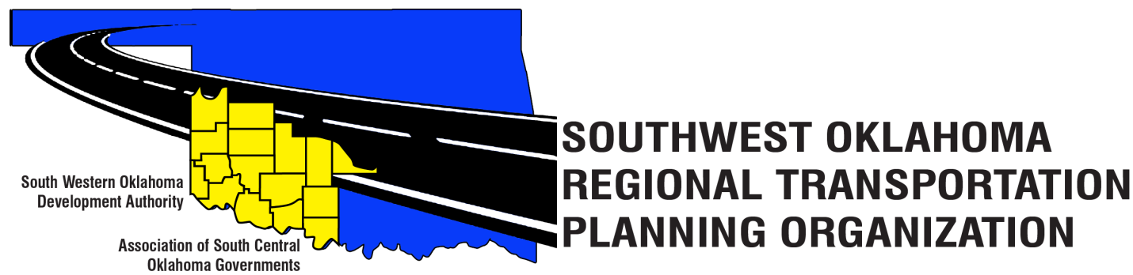

SORTPO Policy Board

Special Meeting Agenda

August 30, 2018, 10:30 a.m.
Western Technology Center  Adult Education Bldg,  621 Sooner Dr.  Burns Flat, OK 73624 | Red River Technology Center  JDM Business Center, Rm B113  3300 W. Bois D’Arc  Duncan, OK 73533

- Call to Order.
- Roll Call.
- Introduction of Guests.
- Approval of the minutes for the June 28, 2018 meeting.
- Old Business.
- Discuss and consider comment provided by Tech. Committee on the 2040 LRTP’s listed in 6 A-D:
- 2040 Kiowa County Long Range Transportation Plan
- 2040 Washita County Long Range Transportation Plan

- Discuss and consider establishing a 30 day public review and comment period for (September 4, 2018- October 3, 2018) for the 2040 LRTP’s listed in 7 A-D:
- 2040 Kiowa County Long Range Transportation Plan
- 2040 Washita County Long Range Transportation Plan

- New Business.
- Reports and Comments.
- Adjourn.

