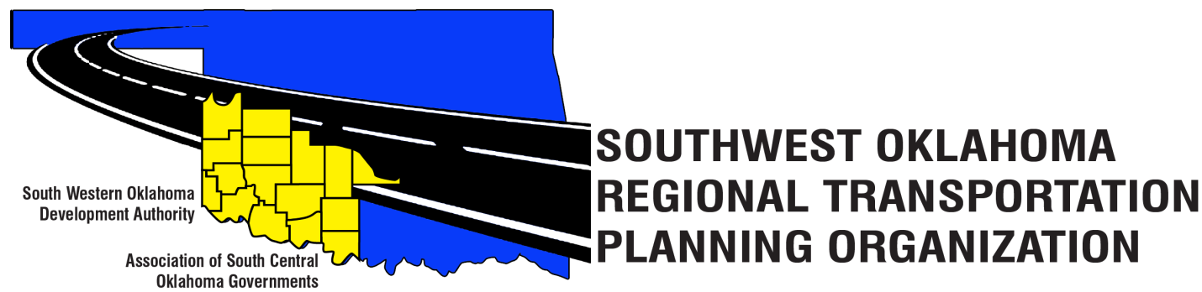

SORTPO

Policy Board Minutes
April 26, 2018
10:30 a.m.
Western Technology Center | Red River Technology Center
Adult Education Bldg | JDM Business Center, Rm B113
Burns Flat, OK 73624 | Duncan, OK 73533

Policy Board Members | P/A | Policy Board Members | P/A
Brent Almquist | P | Lyle Miller | P
Anita Archer | P | Cendie Newman | A
Tim Binghom | P | Lyle Roggow | P
Dale Bunn | P | Sandy Settle | P
Kirk Butler | P | Heather Sheppard | P
Jerry Dean | A | Mark Skiles | P
Jay Earp | P | Clark Southard | P
Marilyn Feaver | A | Bill Spurlock | P
Shawn Freie | P | Larry Thoma | A
Debora Glasgow | A | Tom Zigler | P

Representing SORTPO:
Becky Cockrell, SORTPO Director
Julie Sanders, Consultant
Amy Crowe, SWODA Accountant

1. Call to Order:
Meeting called to order at 10:37 a.m. by Chairman Lyle Miller.
2. Roll Call – Introductions:
Becky Cockrell, SORTPO Director – quorum declared

3. Introduction of Guests.
Amy Crowe, SWODA Accountant

4. Approval of Minutes:
Motion to approve meeting minutes from March 29, 2018 meeting was made by Tom Zigler and second by Clark Southard.

Motion passed.

5. Old Business - N/A

6. New Business- N/A

7. Discuss and consider adopting Resolution # 2018-1 approving Amendment #1 to the FFY 2017-2018 Planning Work Program (PWP).
Motion was made to adopt the Resolution #2018-1 and to approve the Amendment #1 to FFY 2017-2018 Planning Work Program (PWP) as it was presented with no further changes. Motion was made by Mark Skiles and seconded by Clark Southard.

Motion passed.

8. Discuss and consider setting a 45-day public review and comment period (April 30,2018- June 13,2018 ) prior to adopting Amendment #2 to the Public Participation Plan (PPP).
Motion was made to set a 45-day public review and comment period from (April 30, 2018 – June 13, 2018) Motion was made by Kirk Butler and seconded by Heather Sheppard.

Motion Passed.

Motion was made to consider adopting Amendment #2 to the Public Participation Plan (PPP) after the public review and comment period. Motion was made by Bill Spurlock and seconded by Clark Southard.

Motion Passed.

9. Discuss and consider setting a 10-day public review and comment period (June 4, 2018- June 13, 2018 prior to the adoption of the Limited English Proficiency Plan (LEP).
Motion was made to set 10 day public review comment period (June 4, 2018 – June 13, 2018) by Clark Southard and seconded by Kirk Butler.

Motion Passed.

10. Reports and Comments
Becky Cockrell reported that the Policy Board will not be meeting May 24, 2018. That they will return on June 21, 2018.

11. Adjourn.
Motion to adjourn meeting was made by Bill Spurlock and seconded by Clark Southard.

Motion passed

ATTEST:

___________________________ _________________________
(Chairman) (Secretary)

