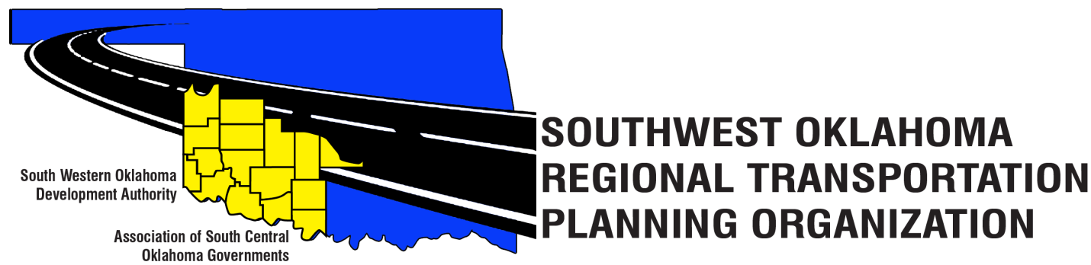
SORTPO Technical Committee
Agenda
August 16, 2018 10:00 a.m.

Western Technology Center  Adult Education Bldg,  621 Sooner Dr.  Burns Flat, OK 73624 | Red River Technology Center  JDM Business Center, Rm B113  3300 W. Bois D’Arc  Duncan, OK 73533

1. Call to Order.
2. Roll Call.
3. Introduction of Guests.
4. Approval of the minutes for the June 21, 2018 meeting.
5. Old Business.

6. Discuss and provide comments for LRTPs listed in 6 A-D and forward comments to the SORTPO Policy Board.
- 2040 Kiowa County Long Range Transportation Plan
- 2040 Washita County Long Range Transportation Plan
7. Discuss, consider and recommending to the SORTPO Policy Board public review and comment period for (September 4, 2018- October 3, 2018) for the LRTP’s listed in 7 A-D:
- 2040 Kiowa County Long Range Transportation Plan
- 2040 Washita County Long Range Transportation Plan
8. New Business.
9. Reports and Comments.
10. Adjourn.

