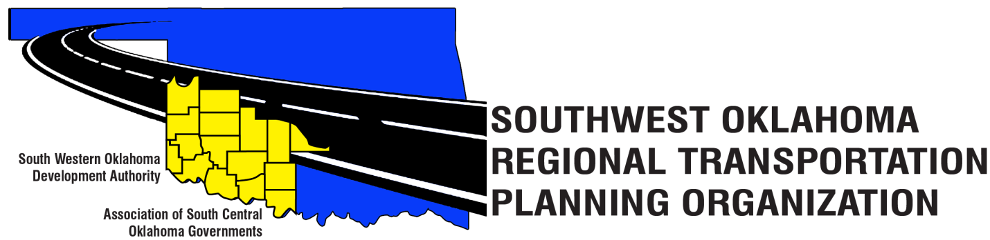

SORTPO

Technical Committee Minutes
August 16, 2018
10:00 a.m.
Western Technology Center | Red River Technology Center
Adult Education Bldg 621 Sooner Dr. | JDM Business Center, Rm B113
Burns Flat, OK 73624 | Duncan, OK 73533

Technical Committee Members | P/A | Technical Committee Members | P/A
Bryce Bohot | A | Jim Mason | P
Danny Britton | P | Kevin Ouellette | A
Elesia Church | P | John Sheppard | P
Becky Cockrell | P | Cole Vonfeldt | P
Lee Litterell | A | Basil Weatherly | P
 |  | Tom Zigler | P

Representing SORTPO:
Julie Sanders, Consultant; Shelby Templin, ODOT RTPO Coordinator; Amy Crowe, SWODA accountant

1. Call to Order:
Meeting called to order by Becky Cockrell, SORTPO Director
2. Roll Call – Introductions:
Becky Cockrell, SORTPO Director - quorum declared

3. Introduction of Guests
No guest at this meeting.

4. Approval of Minutes:

Motion to approve meeting minutes for the June 21, 2018 was made by Basil Weatherly and second by Tom Zigler.
Motion Passed

5. Old Business
N/A

6. Discuss and provide comments for 2040 Kiowa Co. & 2040 Washita Co. LRTP’s listed in 6 A-B and forward comments to the SORTPO Policy Board.

- Verify County border on Foss State Park
- Verify income level survey data
- Suggested needing someone from Kiowa Co to look over LRTP

Motion to forward LRTP’s to the SORTPO Policy Board was made by Cole Vonfeldt and seconded by Elesia Church.
Motion passed.

7. Discuss, consider and recommending to the SORTPO Policy Board public review and comment period for ( September 5, 2018 – October 3, 2018) for the LRTP’s listed in 7 A-B.

- Julie Sanders explained that this is a standard process within ODOT policy and producers.

Motion to recommend public review and comment period to the SORTPO Policy Board was made by John Sheppard and seconded by Jim Mason.

Motion Passed

8. New Business.
- Becky Cockrell, SORTPO Director reminded the Technical committee that Julie Sanders, Laura Chaney and herself will be out of town next week for a National Tools of the Trade Transportation Planning Conference that will have a workshop in regards to the 2020 Census training. The SORTPO Policy Board meeting has been moved to August 30th, 2018.

9. Reports and comments.
- Becky Cockrell, SORTPO Director informed the committee that her and Debora Glasgow, SWODA Executive Director have contacted the Census Bureau to have SWODA become the contact person for all eight counties in SWODA area.
- Shelby Templin, ODOT RTPO Coordinator informed the committee that Elk City has tentatively scheduled a STEP workshop. More information will be provided soon and encourages all rural communities to attend.
- Tom Zigler, ASCOG Director informed the committee that Steve Kelly is no longer with ASCOG and Tom will be filling the position until future notice.

10. Adjourn
Motion to adjourn was made by Jim Mason and second by Elesia Church.
Motion passed

ATTEST:

__________________________________
(Chairman)

