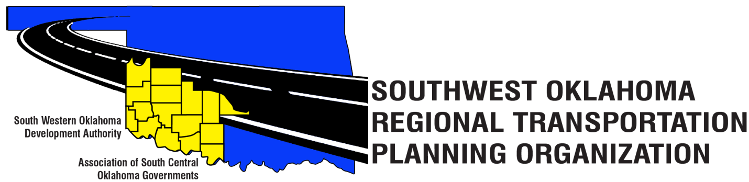

SORTPO Policy Board

Meeting Agenda

September 27, 2018, 10:30 a.m.
Western Technology Center  Adult Education Bldg,  621 Sooner Dr.  Burns Flat, OK 73624 | Red River Technology Center  JDM Business Center, Rm B113  3300 W. Bois D’Arc  Duncan, OK 73533

- Call to Order
- Roll Call
- Introduction of Guests
- Approval of the minutes for the August 30, 2018 meeting.
- Old Business
- Discuss and consider approving the FFY 2017-2018 Joint Certification statement to ODOT for the SORTPO regional transportation planning process.

- Discuss and consider endorsing the FFY 2018-2019 State Planning & Research (SPR) funding agreement between SWODA Board of Trustees and the Oklahoma Department of Transportation.

8. Discuss and consider endorsing the contract between the SWODA Board of Trustees and Julie Sanders, Consultant for transportation planning services for the FFY 2018-2019.

9. Discuss and consider adopting Resolution No. 2018-4 approving the FFY 2018-2019 Planning Work Program (PWP).

10. Discuss and provide comments for the Long Range Transportation Plans listed in 10 A-B.

A. 2040 Grady County Long Range Transportation Plan
B. 2040 McClain County Long Range Transportation Plan

11. Discuss and consider establishing a 30-day public review and comment period for the Long Range Transportation Plans listed in 11 A-B.

A. 2040 Grady County Long Range Transportation Plan
B. 2040 McClain County Long Range Transportation Plan

12. Discuss and consider approving a letter of support for the City of Comanche, OK TAP Project.

13. New Business
14. Reports and Comments
15. Adjourn

