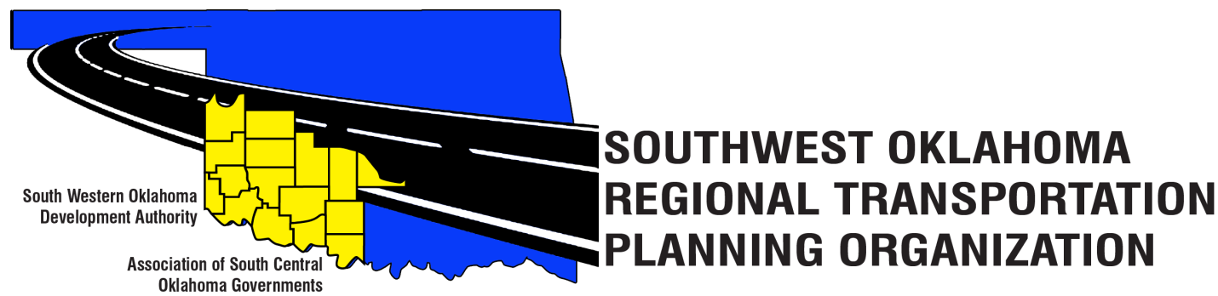

SORTPO

Policy Board Minutes
June 28, 2018
10:30 a.m.
Western Technology Center | Red River Technology Center
Adult Education Bldg | JDM Business Center, Rm B113
Burns Flat, OK 73624 | Duncan, OK 73533

Policy Board Members | P/A | Policy Board Members | P/A
Brent Almquist | P | Lyle Miller | P
Anita Archer | A | Cendie Newman | P
Tim Binghom | P | Lyle Roggow | A
Dale Bunn | P | Sandy Settle | P
Kirk Butler | P | Heather Sheppard | P
Jerry Dean | A | Mark Skiles | P
Jay Earp (Cole Vonfeldt) (P) | A | Clark Southard | P
Marilyn Feaver | P | Bill Spurlock | P
Shawn Freie | P | Larry Thoma | A
Debora Glasgow | P | Tom Zigler | P

Representing SORTPO:
Becky Cockrell, SORTPO Director
Julie Sanders, Consultant
Amy Crowe, SWODA Accountant

1. Call to Order:
Meeting called to order at 10:45 a.m. by Chairman Lyle Miller.

2. Roll Call – Introductions:
Becky Cockrell, SORTPO Director – quorum declared

3. Introduction of Guests.
Shelby Templin, ODOT
Laura Chaney, ODOT

4. Approval of Minutes:
Motion to approve meeting minutes from April 26, 2018 meeting was made by Bill Spurlock and second by Clark Southard.

Motion passed.

5. Old Business - N/A

6. Discuss, provide comment and consider adopting Resolution#2018-2 and approving Amendment #2 to the Public Participation Plan (PPP).

Motion to approve adopting Resolution #2018-2 and approve Amendment #2 to the Public Participation Plan (PPP) was made by Kirk Butler and second by Bill Spurlock.

Motion passed

7. Discuss, provide comment and consider adopting Resolution#2018-3 approving the Limited English Proficiency Plan (LEP).

Motion to approve adopting Resolution #2018-3 approving the Limited English Proficiency Plan (LEP) was made by Heather Sheppard and second by Mark Skiles.

Motion passed.

8. New Business.
  - Discuss and consider canceling the August 23rd meeting and scheduling a special meeting August 30th.
Motion to approve canceling the August 23rd, 2018 meeting and the scheduling of a special meeting to be held on August 30th, 2018 was made by Heather Sheppard and second by Mark Skiles.

Motion passed

Ton Zingler, ASCOG- brought up a concern the Technical Board discussed at their last meeting. It was discussed that an attorney should be reviewing any policies and documents that SORTPO approves to make sure SORTPO stays within the state and federal regulations.
Laura Chaney, ODOT- expressed her agreement that SORPTO stays well within ODOT guidelines and ODOT is reviewed, verified and approved by an attorney before any documents are sit in place; as long as SORTPO polices and documents agree with ODOT than SORPTO is operating within any and all state and federal regulations.
The Policy Board discussed this issue and decided not to take action at this time.

Tom Zingler, ASCOG – requested SORPTO to commission a letter of support for funding the I-35 and St HWY 9 west project.

Motion to approve SORPTO sending a letter of support for funding this project in ASCOG’s area was made by Marilyn Feaver and second by Bill Spurlock.

Motion passed

Kirk Butler, Jackson County Commissioner – also requested a letter for funding support from SORPTO for the 2018 Build Grant Proposal project.

Motion to approve SORTPO sending a letter of support for funding this project in SWODA’s area was made by Tim Binghom and second by Debora Glasgow

Motion passed

9. Reports and Comments.
Shelby Templin, ODOT – TAP Program official release applications on July 1st, 2018, online website submissions are the only accepted and scored applications.
Key Dates: July 1st Nov 30th Project site visits and project review sessions conducted upon request.
Oct 1st – TAP Application period opens for submissions.
Nov 30th – TAP Application period closes by 4:00pm.
March – ODOT will announce final project selections and awards.
Shelby also invited SORTPO to participate in the federal initiative program: Safety Transportation for Every Pedestrian (STEP); this consist of a one day workshop/ class that is more beneficial to rural areas due to lack of cross walks.

Shelby continued to inform the Policy Board about the Census 2020 boundary line changes and urged the counties to verify their boundary lines before the Census Bureau places default boundary lines. Becky Cockrell has a list of counties that still need to confirm their boundary lines.

10. Adjourn.
Motion to adjourn meeting was made by Tim Binghom and seconded by Bill Spurlock.

Motion passed

ATTEST:

___________________________ _________________________
(Chairman) (Secretary)

