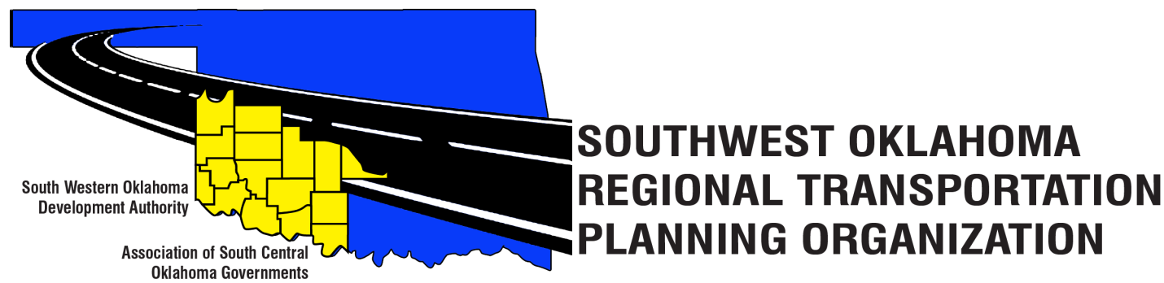

SORTPO

Policy Board Minutes
August 30, 2018
10:30 a.m.
Western Technology Center | Red River Technology Center
Adult Education Bldg | JDM Business Center, Rm B113
Burns Flat, OK 73624 | Duncan, OK 73533

Policy Board Members | P/A | Policy Board Members | P/A
Brent Almquist | P | Lyle Miller | P
Anita Archer | P | Cendie Newman | P
Tim Binghom | P | Lyle Roggow | P
Kevin Bloss | A | Sandy Settle | P
Dale Bunn | A | Heather Harding | P
Kirk Butler | P | Mark Skiles | P
Jerry Dean | A | Clark Southard | A
Jay Earp | P | Bill Spurlock | P
Marilyn Feaver | P | Larry Thoma | A
Shawn Freie | P | Tom Zigler | P
Debora Glasgow (Michael Ryburn) | A

Representing SORTPO:
Becky Cockrell, SORTPO Director
Julie Sanders, Consultant
Amy Crowe, SWODA Accountant
Michael Ryburn, Deputy Executive Director SWODA

1. Call to Order:
Meeting called to order at 10:35 a.m. by Chairman Lyle Miller.

2. Roll Call – Introductions:
Becky Cockrell, SORTPO Director – quorum declared

3. Introduction of Guests.
Shelby Templin, ODOT
Mike Dixon, ASCOG
Chuck Ralls, City Manager of Comanche

4. Approval of Minutes:

- Motion to approve meeting minutes from June 28, 2018 Policy Board meeting was made by Bill Spurlock and second by Heather Harding.

Motion passed.

5. Old Business – N/A

6. Discuss and consider comments provided by Tech Committee on the 2040 LRTP’s listed in 6-A-B:
A. 2040 Kiowa County LRTP
B. 2040 Washita County LRTP

- No comments or discussion from Policy Board on the 2040 Kiowa LRTP or the 2040 Washita County LRTP at this time.

7. Discuss and consider establishing a 30 day public review and comment period for (September 4, 2018 – October 3, 2018) for the 2040 LRTP’s listed in 7 A-B:
A. 2040 Kiowa County LRTP
B. 2040 Washita County LRTP

- Motion to approve 30 day public review and comment period of September 4, 2018 - October 3, 2018 for the 2040 Kiowa LRTP and the 2040 Washita County LRTP was made by Mark Skiles and second by Bill Spurlock.

Motion passed

8. New Business: N/A

9. Reports and Comments:
- Becky Cockrell, SORTPO Director- updated the Policy Board on SWODA’s efforts on becoming the contact person for their eight counties with the Census Bureau to help ensure accurate information is being reported.
- Shelby Templin, ODOT – announced the date for the STEP (Safe Transportation for Every Pedestrian) workshop; which will be held at the Elk City Convention Center on September 26, 2018. Everyone is encouraged to attend and learn ways to make their city/ towns safer for pedestrians.

ATTEST:

___________________________ _________________________
(Chairman) (Secretary)

