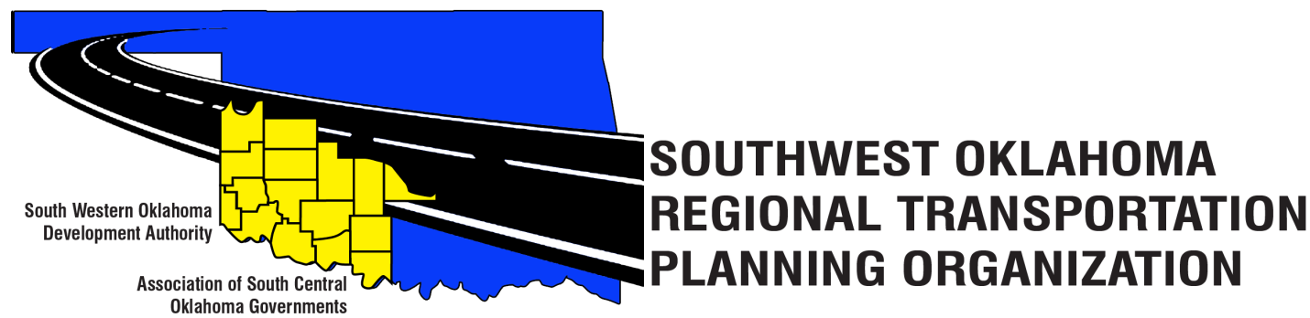

SORTPO

Policy Board Minutes
September 27, 2018
10:30 a.m.
Western Technology Center | Red River Technology Center
Adult Education Bldg | JDM Business Center, Rm B113
Burns Flat, OK 73624 | Duncan, OK 73533

Policy Board Members | P/A | Policy Board Members | P/A
Brent Almquist | P | Lyle Miller | P
Anita Archer | P | Cendie Newman | P
Tim Binghom | P | Lyle Roggow | P
Kevin Bloss | P | Sandy Settle | A
Dale Bunn | A | Heather Harding | P
Kirk Butler | P | Mark Skiles | A
Jerry Dean | A | Clark Southard | P
Jay Earp | P | Bill Spurlock | A
Marilyn Feaver | A | Larry Thoma | A
Shawn Freie | P | Tom Zigler | P
Debora Glasgow | P

Representing SORTPO:
Becky Cockrell, SORTPO Director
Julie Sanders, Consultant
Carol Binghom, SWODA

1. Call to Order:
Meeting called to order by Chairman Lyle Miller.

2. Roll Call – Introductions:
Becky Cockrell, SORTPO Director – quorum declared

3. Introduction of Guests.
Braden Cale, ODOT
Carol Binghom, SWODA
Mike Dixon, ASCOG, Ronnie Ward, ASCOG

4. Approval of Minutes:

- Motion to approve meeting minutes from August 30, 2018 Policy Board meeting was made by Heather Harding and second by Clark Southard.
Motion passed.

5. Old Business – N/A

6. Discuss and consider approving the FFY2017-2018 Joint Certification statement to ODOT for the SORTPO regional transportation planning process.

- Motion to approve the FFY 2107-2018 Joint Certification to ODOT approving SORTPO has completed all the criteria for the regional transportation planning process. Motion was made by Anita Archer and second by Tom Zigler.
Motion Passed

7. Discuss and consider endorsing the FFY 2018-2019 State Planning & Research (SPR) funding agreement between SWODA Board of Trustees and the Oklahoma Department of Transportation.

- Motion to approve the endorsement of the FFY 2018-2019 State Planning & Research (SPR) funding agreement between SWODA Board of Trustees and the Oklahoma Department of Transportation. Motion was made by Tim Binghom and second by Kirk Butler.
Motion passed

8. Discuss and consider endorsing the contract between the SWODA Board of Trustees and Julie Sanders, Consultant for Transportation planning services for the FFY 2018- 2019.
- Motion to approve the endorsement of the contract between the SWODA Board of Trustees and Consultant Julie Sanders for Transportation planning services for the FFY 2018-2019. Motion was made by Kirk Butler and second by Heather Harding.
Motion Passed

9. Discuss and consider adopting Resolution No. 2018-4 approving the FFY 2018-2019 Planning Work Program.
- Motion to adopting Resolution No. 2018-4 approving the FFY 2018- 2019 Planning Work Program (PWP). Motion was made by Clark Southard and second by Shawn Freie.
Motion Passed

10. Discuss and provide comments for the Long Range Transportation Plans listed in 10 A-B.
A. 2040 Grady County Long Range Transportation Plan
B. 2040 McClain County Long Range Transportation Plan

- Julie Sanders discussed that the documents for Grady and McClain that the Technical Committee had no comments on the documents. Mrs.Sanders is waiting on the TAZ maps for Grady County from Landlocked before she can finish up the Grady County plan.
- Landlocked has been developing the TAZ maps for Grady and McClain. McClain County TAZ maps will be finished this week and Grady will be done next week.

11. Discuss and consider establishing a 30-day public review and comment period for the Long Range Transportation Plans listed in 11 A-B.
A. 2040 Grady County Long Range Transportation Plan
B. 2040 McClain County Long Range Transportation Plan

- Motion to approve a 30-day public review and comment period for the Long Range Transportation Plans listed in 11 A-B for the time frame of Oct 14th – Nov 14th, 2018. Motion was made by Tom Zigler and second by Clark Southard.
Motion Passed

12. Discuss and consider approving a letter of support for the City of Comanche, OK TAP Project.

- Motion to approve a letter of support for the City of Comanche, OK TAP Project. Motion was made by Clark Southard and second by Debora Glasgow.
Motion Passed

13. New Business – N/A

14. Reports and Comments.

- Becky Cockrell, SORTPO Director advised the Board of the upcoming topics for the October 25th meeting: Approving the Kiowa and Washita County plans and providing comments for on Grady and McClain County. Becky asked the board their recommendations for the November 15th meeting to keep it the same day as Tech. Committee or move it to November 29th ; board agreed to keep it on November 15th.
- Braden Cale, ODOT reported on the Safe Transportation for Every Pedestrian (STEP) workshop that was held in Elk City it was very informative, good turn out and hope to have more.

15. Adjourn

- Motion to adjourn the SORTPO Policy Meeting. Motion was made by Tim Binghom and second by Heather Harding.
Motion Passed

ATTEST:

___________________________ _________________________
(Chairman) (Secretary)

