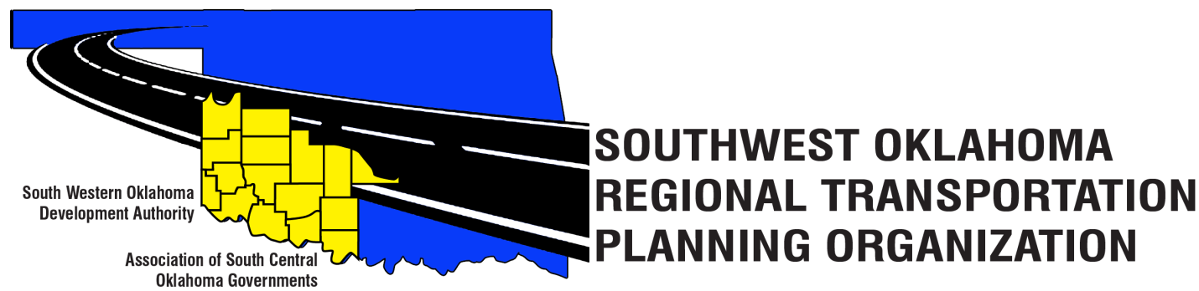
SORTPO Technical Committee
Agenda
October 11, 2018 10:00 a.m.

Western Technology Center  Adult Education Bldg,  621 Sooner Dr.  Burns Flat, OK 73624  580-562-3181 | Red River Technology Center  JDM Business Center, Rm B113  3300 W. Bois D’Arc  Duncan, OK 73533  580-255-2903

Technical Committee Members | Location | Technical Committee Members | Location
Bryce Bohot | Duncan | Jim Mason | Burns Flat
Danny Britton | Burns Flat | Kevin Ouellette | Duncan
Elesia Church | Burns Flat | John Sheppard | Duncan
Becky Cockrell | Burns Flat | Cole Vonfeldt | Duncan
Lee Litterell | Burns Flat | Basil Weatherly | Burns Flat
 |  | Tom Zigler | Duncan
- Call to Order
- Roll Call
- Introduction of Guests
- Approval of the minutes for the September 20, 2018 meeting.
- Discuss and consider comments received during the public review and comment period for LRTP’s listed in 4 A-B and forward comments to the SORTPO Policy Board.
A. 2040 Kiowa County Long Range Transportation Plan
B. 2040 Washita County Long Range Transportation Plan
- Discuss and recommend to the SORTPO Policy Board adopting a resolution approving:
A. 2040 Kiowa County Long Range Transportation Plan
B. 2040 Washita County Long Range Transportation Plan
- Discuss and recommend approval to the SORTPO Policy Board the 2019 scheduled meetings.
- Old Business
- New Business
- Reports and Comments
- Adjourn

